Wytch Farm Landscape and Access Enhancement Fund
How to Apply
Background
The Dorset Area of Outstanding Natural Beauty is a nationally important protected landscape, with vibrant communities and a wealth of wildlife and heritage. Within the AONB is the largest onshore oilfield in Europe, at Wytch Farm near Corfe Castle. As part of a planning application to extend the working life of the oilfield by a further 20 years, the oilfield operator, Perenco UK has provided a sum of £1.7 million for landscape, biodiversity and sustainable transport projects to enhance the landscape. This sum is to be used to fund projects that compensate for the environmental impacts of the further retention of the oilfield’s infrastructure in the landscape.
How to Apply
If you would like to apply to this fund, please assess your project against the information below to check whether you fulfil the criteria. Applications are to be made on a form downloadable from the following link: Wytch Farm Fund Application Form.
What kinds of project can be funded?
Projects can be funded which:
- Strengthen the character of the surrounding landscape by heathland and acid grassland mosaic creation, conservation, enhancement and management.
- Enhance biodiversity by the conservation, enhancement and management of boundary features (hedgerows, veteran trees and earth banks), woodlands (e.g. through Rhododendron control) and rural lanes.
- Improve rights of way and / or facilities for no-car access and conserving tranquillity.
Funding is to be targeted to physical works which achieve these aims. Project management time to deliver a practical project can be included within the overall proposal but funds will not be awarded to projects with a disproportionate amount of revenue costs (e.g., officer time).
Should projects be in a certain area?
The fund is available for projects near to the oilfield infrastructure. All projects should be within either the Oilfield’s zone of visual influence or the following two landscape character areas defined in ‘Conserving Character, Landscape Character Assessment and Management Guidance for the Dorset AONB’:
- South Purbeck Heaths; and
- Rempstone Wooded Pastures.
The landscape character areas and zone of visual influence are within the areas indicated on the map below.
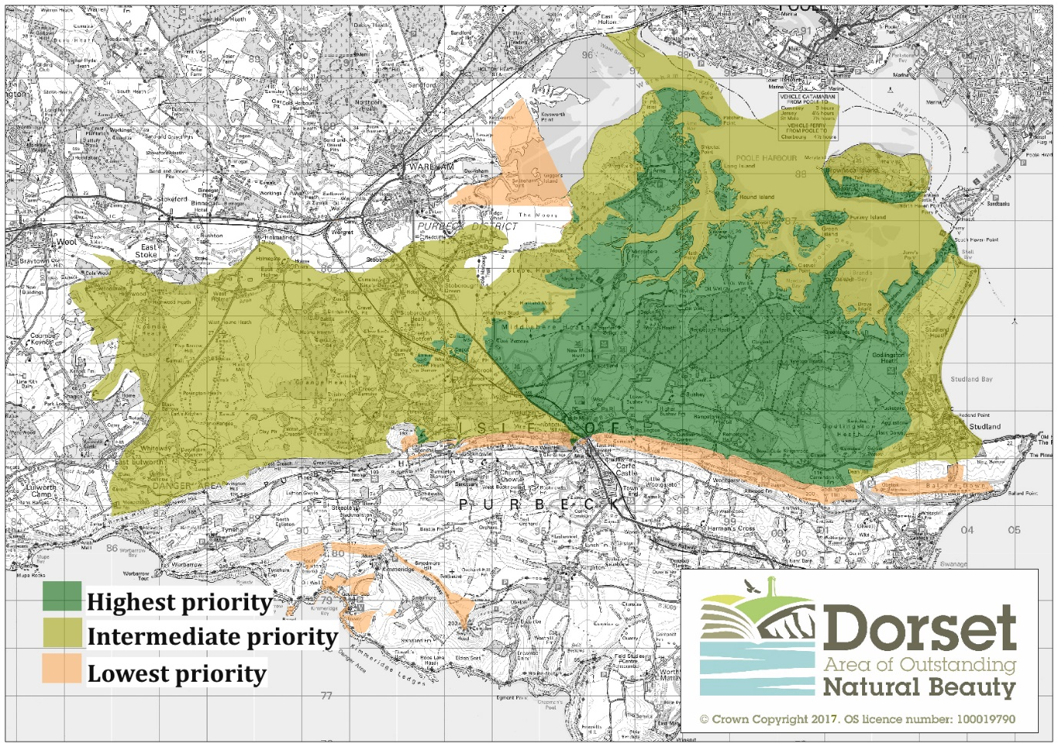
Your project must be based within the highest, lowest or intermediate priority areas shown on the map.

Projects will be assessed as being in highest, intermediate or lowest priority areas depending on their location:
- Highest priority area: projects within the South Purbeck Heaths or Rempstone Wooded Pastures character areas and within the zone of visual influence.
- Intermediate priority area: projects located within the South Purbeck Heaths or Rempstone Wooded Pastures character areas but outside the zone of visual influence.
- Lowest priority area: projects outside the South Purbeck Heaths or Rempstone Wooded Pastures character areas but within the zone of visual influence (including Kimmeridge).
The South Purbeck Heaths Landscape Character Area includes the villages of Arne, Ridge, Stoborough and West Holme and part of Studland village.
The Rempstone Wooded Pasture Landscape Character Area includes the majority of Studland village, the northern edge of Corfe Castle village, East Creech and part of East Lulworth.
The zone of visual influence includes areas around Kimmeridge.
Projects must be able to demonstrate direct or indirect benefits to the landscape character areas. They may therefore be sited in the wider zone of visual influence (see map), but still need to demonstrate benefit within the South Purbeck Heaths and Rempstone Wooded Pasture Landscape Character Areas.
If you have a project which covers a wider area and are seeking a grant, it must be clearly shown how you will spend the amount of funding applied for within the priority areas outlined above. For high value or more complex projects, applicants may be invited to present their project to a panel meeting.
Who can apply?
Anyone (individual, group or organisation) can apply to the fund.
Assessment
Projects will be assessed with regard to the extent to which they meet the three objectives outlined above, as well as the amount of match funding / in kind support being provided. Other factors which will be assessed will include the amount of community support projects have and their deliverability and sustainability. Applications will be assessed by a panel using the information provided on the application form, but applicants may also be invited to provide further information. It is therefore important to answer all the questions in full. Grants may be subject to relevant permissions being secured. Feedback on this process would be welcomed so that we can continually improve our application process.
Projects of all sizes will be considered. All projects will need to demonstrate value for money. For further information or to discuss your project, please contact Caroline Kelly.
Conditions of grant
There are conditions that you will have to abide by to ensure the fund is used in the best way for its intended purpose. For example, providing match funding, delivering outputs as stated in your application form, or timescales for delivery. These will be included in a grant offer letter. Grants will be paid in arrears. Applicants must provide agreed evidence of expenditure e.g., original receipts.
Applicants must be able to show how the project will be maintained once it is completed, e.g., through ten-year aftercare / monitoring process.
For further information or to discuss complex projects in more detail, please contact:
Caroline Kelly, AONB Wild Purbeck Project Coordinator, 01305 228232 or caroline.j.kelly@dorsetcouncil.gov.uk

