Wytch Farm Landscape and Access Enhancement Fund
Application Form

For Office Use | Date received: | Ref No:

Section A – About You
Name of applicant:
Project Title:
Amount of grant requested: |  | Total Project cost:
Main contact:
Position held in organisation:
Contact address and postcode:
Telephone number:
E-Mail address:
Organisation status please state (e.g. registered charity, public sector (town / parish council), landowner, company, community interest company, other):
Your project must be based within the highest, lowest or intermediate priority areas shown on the map below.
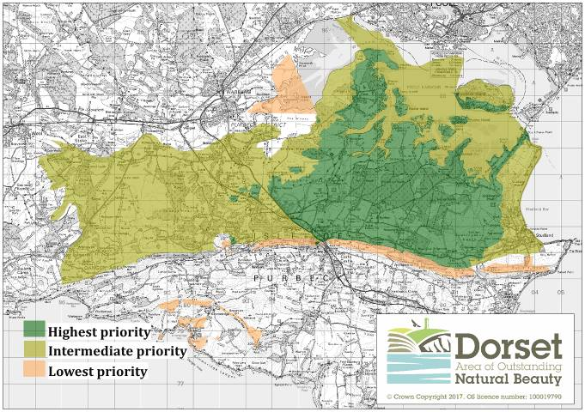

Section B – Project Details
Entry fields will expand to fit text as required; however we do not expect the final form to exceed 7 pages in total. For larger projects (over £20,000 grant requested) you may be asked to provide further information for the panel to consider.
- Project location and coverage:
The project needs to be within the highest, intermediate, or lowest priority areas shown on the map above. Please mark the location of your project on the map at the end of this form.
- Proposed start date:
- Proposed end date:

- Please provide a summary of your project (describe the project as a whole, this should cover all items/activities you are seeking funding for) (Max 200 words). Explain what the funding will be used for.
- Will the funding be for:
The project as a whole or

For a specific part of the project

Which of the following objectives does your project meet (tick all that apply):
- Strengthening landscape character through habitat creation, conservation, enhancement and management of heathland or acid grassland
- Enhancing biodiversity through conservation, enhancement and management of boundary features, woodlands and rural lanes
- Improving rights of way and / or facilities for no-car access and conserving tranquillity

Describe how it meets these objectives (Max 300 words)
- Could this project go ahead without funding from the Landscape and Access Enhancement Fund? Yes / No. If no, please explain why not.
- Please what the wider benefits of your project are.
- What need is your project designed to meet? What level of community or local support does your project have (including evidence e.g., feasibility, research, letters of support)?

- How will you monitor the project and measure the benefits?
- Have you had experience delivering other projects? Please give one or two examples to illustrate your track record of project delivery.
- Do you have any partners in your project? If so, please explain who they are and their role.
- What permissions do you need to carry out your project? Have you obtained all these permissions? If not when do you expect to have those agreed?
- How will you ensure project is delivered sustainably? E.g., through natural regeneration, use of local seed / materials / contractors
- How will you maintain the asset after the funding has finished? Include information on ongoing management and / or aftercare.
Section C – Financial Details
If your proposal is part of a bigger project, please list the relevant items only here and outline the wider benefits of the overall project in the text.
Project Costs
List all items of expenditure | In Kind | Cash | Total
Total A

Other Income
List all other sources of income | In Kind | Cash * | Total
Wytch Farm Landscape and Access Enhancement Fund request
Total B
Total A = Total B
* Please indicate what stage any other funding applications (or similar) have reached i.e., 1 = Application in process 2 =Awaiting confirmation (please put decision date) 3= Confirmed
AUTHORISED SIGNATORY This section must be signed by someone with the required authority (e.g., Chairperson). An electronic signature is acceptable. I confirm that, to the best of my knowledge and belief, all the information in this application is true and correct. I understand that, I maybe asked for additional information. In the event that the project is unsuitable, I agree to these details being passed to an appropriate body for further assistance.
Signed |  | Print name
Position |  | Date

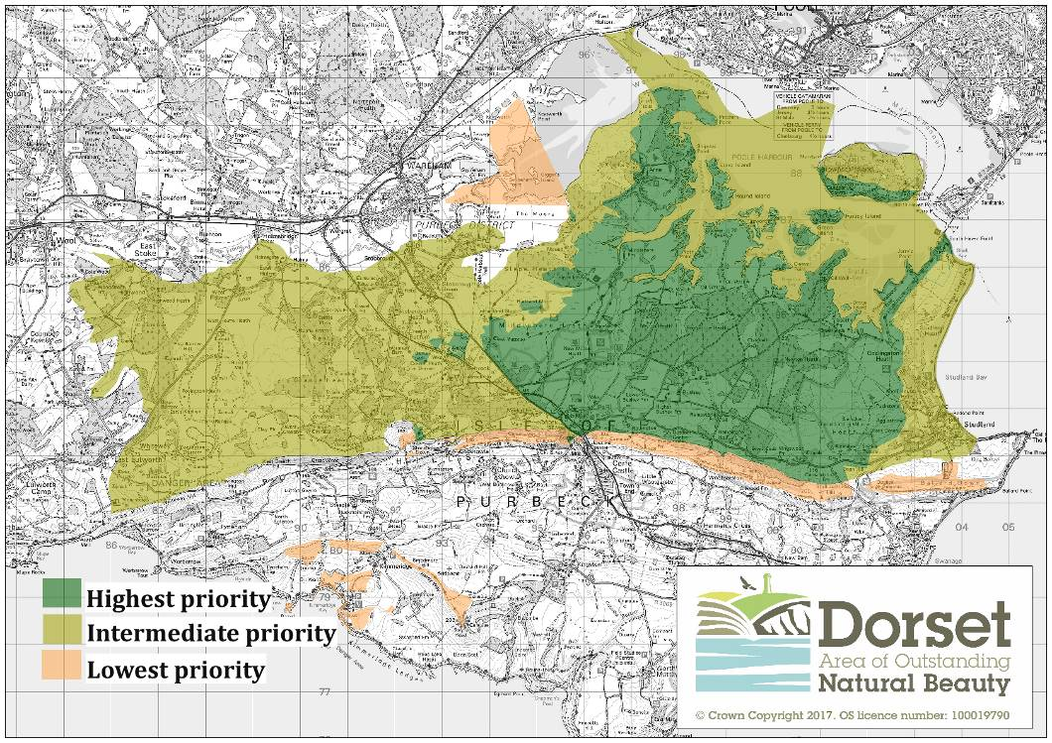
Please mark the location and boundaries of your project on this map or explain in your description where it is (if submitting electronically)

