Guidance for Applicants to the Farming in Protected Landscapes Programme
An introduction to the Farming in Protected Landscapes Programme
The Farming in Protected Landscapes (FiPL) programme has been created by Defra and it forms part of the Government’s Agricultural Transition Plan.

It provides funds to allow farmers and land managers to work with Protected Landscape organisations (National Park Authorities and Areas of Outstanding Natural Beauty teams) to provide benefits for nature, climate, people and places. The programme will run until 31 March 2025.

A more detailed overview of the programme

Our Protected Landscapes (PLs) – our National Parks and National Landscapes - are special and unique and need to be managed, enhanced and protected while also supporting the farmers and communities who work within them and the wider local economy.

The Farming in Protected Landscapes programme, which operates in England, provides additional investment in these places to allow farmers to work in partnership with Protected Landscape bodies to deliver bigger and better outcomes for the environment, for people and for the place.

Protected Landscapes can make an important contribution to:

- Climate – delivering net zero with nature and nature-based solutions to help communities adapt to the unavoidable effects of climate change;
- Nature – playing a leading role in the delivery of the Nature Recovery Network and achieving the Prime Minister’s commitment to protect 30% of land by 2030;
- People – providing a natural health service that will improve the nation’s public health and wellbeing through increased access to nature across all parts of society, as part of our green recovery;
- Place – creating centres of excellence and green innovation that are flourishing places to live and work, each with a strong identity and cultural heritage, and high recognition as attractive visitor destinations

As part of the Agricultural Transition Plan, the government has committed to help farmers and land managers deliver against these four areas, in a holistic way - in order to meet the requirements of individual Protected Landscapes, helping strengthen their special importance and enhance their environments and accessibility.

The programme will be delivered by farmers, working in partnership with Protected Landscape teams – Protected Landscape teams and farmers living and working in these areas know the opportunities and challenges facing their landscapes and communities the best. This is an opportunity for Protected Landscapes, farmers, and others within these areas to work better together, leading work at an individual landscape level, building on existing relationships.

The programme is project based and takes a bottom-up approach - this means that funding will support individual projects proposed by farmers, and approved by Local Assessment Panels, which will support Protected Landscapes’ local priorities.

This is a time limited programme (2021-2025) to provide additional investment in our most special places - it will work alongside – not in competition with - existing schemes and add value where it is most needed. Over the longer term, Defra would envision the Environmental Land Management (ELM) schemes playing a specific part across these landscapes, with farmers who lead on Farming in Protected Landscape projects taking part in one of these schemes.

When to apply
The programme runs until 31 March 2025, and no FiPL funding or claims can continue beyond this date.

You can submit your application to the programme at any time, but as funding is limited and the programme is competitive, early applications are encouraged. You should talk to your Protected Landscape team in the first instance.

Before you begin your application
You should ensure you understand the guidance related to each section of the application before completing your application.

Before you apply for your project, you must make sure that you will be able to obtain all the consents and permissions required.
You are responsible for arranging all relevant consents, permissions, exemptions and written advice needed for your application. You will not be offered an agreement without all the necessary consents and permissions being in place.
To make sure you submit a valid application:
- identify the consents and permissions you need as soon as you start your
application. This will depend on any designations attached to the land included in the application and on the activities and items that you are applying for in your application. You can speak to your Protected Landscape FiPL officer for advice on this.
- contact relevant organisations for advice and consents, where required
- be able to provide your Protected Landscape with the evidence needed to support your application.
You may be unaware of some of the consents and permissions you need until after you have received advice. You should talk to your Protected Landscape FiPL officer about the relevant organisations to contact for advice and to gain consent or permission.
Before beginning your application, you should also understand the application process for the programme.
You can find the application form on the website of your local National Landscape or National Park.
Before you apply
- Speak to Rachel Janes on 01305 228256 for advice on the programme including to discuss your ideas, the payment rates and intervention rates for your project.
- Check that you are eligible to apply.
- Read the application questions, guidance and application checklist. Make sure you answer all the questions.
- Have your supporting documents ready to submit with the application form.

How you apply
- Download the application form from the Dorset National Landscape website.
- Complete all relevant sections of the application form.
- Ensure that someone with appropriate authority signs and dates the application.
- Send the application and all required supporting documents, either via email or post:
  - Email: Rachel.janes@dorsetcouncil.gov.uk
  - Post: Dorset National Landscape, hosted by Dorset Council, County Hall, Colliton Park, Dorchester, Dorset DT1 1XJ

Once you have applied
- You should expect to hear back from your Protected Landscape team within a maximum of 8 weeks of your application.

The assessment process

The cost of your project will impact on how it is assessed.

For projects with a total fund request of over £10,000 | For projects with a total fund request of under £10,000
Your application will be assessed by a Local Assessment Panel made up of experts from across your Protected Landscape, including from the farming and land management community, where you project will be given a score using a common scoring system. | Your application will be assessed by a senior member from your Protected Landscape team who has not been involved in providing advice or guidance to your application. They will assess and score your application using the common scoring system. If you submit more than two applications for fund requests under £10,000 over the course of the programme, the third and any further applications will be assessed at the Local Assessment Panel whatever their value.

All projects will be assessed and scored using a common scoring system. You will be scored against the following categories which will be weighted differently for your final score:
- Project outcomes - (40%)
- Value for Money - (20%)
- Sustainability / legacy of project - (20%)
- Ability to deliver - (20%)
The scoring criteria can be found at the end of the guidance document.

There are a number of requirements you must meet for your application to progress and these will be made clear in the application template. Your Protected Landscape will consider whether you meet the essential criteria for the programme (see under ‘who can apply’). If you do not meet the essential criteria, your Protected Landscape will not assess your application further.

Completing Section 1: Applicant Details
This section will ask you to provide details on who you are and what you do. This is to ensure that you are eligible to apply for FiPL funding.
Applications will be accepted from farmers and land managers within an National Landscape or National Park in England, or the Norfolk Broads. The programme may also support activity on other land where that activity can demonstrate benefit to the Protected Landscape, or the Protected Landscape organisation’s objectives or partnership initiatives. Your Protected Landscape FiPL officer can advise on whether your land / project is eligible.
You can check if your land is within the boundaries of a protected landscape on the MAGIC mapping website. Follow these steps:

- select Designations
- select Land-based designations
- select Statutory
- untick all boxes apart from Areas of Outstanding Natural Beauty (England) and National Parks (England).
This programme supports activity on the following areas and features within a protected landscape:
- Farmed or managed areas of arable and other crops, grasslands (temporary and permanent); moorland, woodland and scrub; heathland; in-stream and riparian areas and open waterbodies; land which is or is proposed to be the subject of re-wilding
- Non-farmed areas of a holding, including hardstanding, farmyards, agricultural buildings, historic structures, tracks;
- Protected sites e.g. SSSIs, SACs, SPAs, Ramsar sites or other wildlife rich sites such as wetlands or saltmarsh

Agricultural land is eligible even if it is not actively farmed. The definition of agricultural land is best defined by reference to the Valuation Office Agency definition at the following link:
Rating Manual section 2: valuation principles - Part 6: Exemptions - Part D: Agricultural Premises - Guidance - GOV.UK (www.gov.uk)

This programme does not support works on domestic property.

You can receive funding through the programme for work in the above places if you:
- Are a farmer or land manager (including individuals, charities and some public bodies)
- Are collaborating with an eligible farmer / land manager (or a group of farmers/land managers) to deliver an eligible project
- Own, or have management control of, all the land affected by the project, or have the formal consent of the person who does.

Applications will also be accepted from organisations and individuals delivering projects which are in support of the programme outcomes and the relevant Protected Landscape Management Plan/Priorities, as long as they are applying in collaboration with a farmer or land manager.

A summary of bodies/organisations who are directly eligible

Body/Organisation | Can I apply? | Additional Information
Government departments, executive agencies and NDPBs (for example, Ministry of Defence, Forestry Commission), with exception of the bodies listed below in this table: | No | None
Natural England | Yes | For work on the National Nature Reserves which goes beyond other legal obligations
Other public bodies (including National Park Authorities, The Broads Authority, Conservation Boards and National Landscape Partnerships through their accountable bodies) | Yes | Provided the work goes beyond the duty of regard and other legal obligations
County, Unitary, District, Parish Council and former college farms | Yes | None
Tenants of eligible public bodies | Yes | Ineligible where the work is already a requirement of the tenancy agreement. The public body must countersign the application if the tenant does not have security of tenure for the full term of the agreement.
Tenants of ineligible public bodies | Yes | Ineligible where the work is already a requirement of the tenancy agreement. Tenants must have security of tenure for the full term of the agreement, as the public body cannot countersign the application.
Other organisations and individuals | Yes | Where the proposed activity or works is in support of programme aims

To be eligible to apply, you must have full management control and security of tenure of the land and activities in your application, for the full period of the agreement (including any durability or maintenance requirements);

You are required to declare in the application form that you have this necessary land management control or approval, as stipulated above, to be able to fulfil the requirements of all activities applied for in your application.

If you do not have full control of the land and all such activities, you must get the written consent of all other parties who have management control of the land and activities for the entire period of the agreement and include evidence of approval with your application, or have a countersignature to the application from the landowner (s) / landlord.

If a landlord takes over an agreement from you, they must be eligible to do so.

If a claim were found to be incorrect or ineligible, agreements would allow Protected Landscapes to reclaim the money back from the applicant (if monies had been spent). If no monies had been spent, the contract would be cancelled.
Tenancy

If you are including land in an application that you occupy under a tenancy, including under the Agricultural Holdings Act 1986, Agricultural Tenancies Act 1995 (a Farm Business Tenancy) or equivalent, you must have:
• management control of this land for the duration of any commitments
• control of all the activities needed to deliver the project,
• the consent of the landlord as required.

Landlords

If you are a landlord and can show that you have management control over land which has been let to a tenant, and the activities, you can include that land in an application.

Common land, shared grazing and other collaborative projects
Common land is eligible for support through the Programme. You can apply as a landowner with sole rights, or as a group of commoners acting together. If you are applying on land over which others have rights, you must have agreement from all those who have a legal and active interest in the management of the land.
If the application is made by the landowner who owns the whole common and has sole use and rights to the land, the common can be entered as the landowner’s holding.

Protected Landscape organisations and other bodies may be able to facilitate collaborative projects as a lead or responsible partner. Regardless of who applies, if the application is made by someone who does not have sole use of all the land and where there will be two or more beneficiaries to the agreement:
- an internal agreement must be established, signed by all the parties to the application, specifying the obligations placed on each person and the payments they may expect to receive
- a copy of this internal agreement will need to be submitted before the agreement can commence and may, during the agreement period, need to be supplemented by formal evidence that the internal agreement operates effectively e.g. minutes of recent meetings.
- in all cases where there are 5 or more parties benefiting from or contributing to the delivery of the agreement on common land, a more formal commons association must be established with officers to manage the association.

Collaborative Farmer groups

You can apply to the programme as part of a collaborative farmer group. To do so, you must complete Section 5 of the application template.

You can choose out of the below two options how you and your collaborative farmer group would like to apply.

You can:
- apply through a lead applicant, who takes on the task of distributing resources to the group, managing the application process and reporting on the progress of the project.
- apply through a third party that is not part of the collaborative farmer group but acting on the behalf of the collaborative farmer group (e.g. an environmental charity). The third party will distribute the resources to the group, manage the application process and report on the progress of the project.

If applying through a third party, this could be through your Protected Landscape body who may have experience of working with the whole group or some its members (this would be subject to a panel decision like all other applications). Your Protected Landscape can make individual payments to farmers in the collaborative farmer group or pay for necessary works and activities directly. Your Protected Landscape body will distribute the resources to the group, manage the application process and report on the progress of the project.

You will need to have a partnership agreement(s) between the participants and the lead applicant / applicant body and you must enclose a copy of the partnership agreement (s) with your application. Your Protected Landscape team can support you to develop these if you do not currently have a partnership agreement.

What happens if I am eligible to apply but my holding crosses the boundary of two Protected Landscapes? | If your farm holding crosses the boundary of more than one Protected Landscape and you are interested in applying to the Farming in Protected Landscape programme, please speak to an officer in either of the Protected Landscapes in which your holding lies. They will be best placed to advise which Protected Landscape body you should apply to.

Completing section 2: Project details
This section is designed to allow your Protected Landscape team to understand your project and where it will be delivered. This section also allows Protected Landscape teams to understand any risks of double funding and whether your project will be delivered on a protected site.

Double funding
A project cannot get funding for activities or works that are already being funded by, you are applying for, or have already got funding from, another Government scheme or programme as this would be double funding.
Protected Landscape teams will assess whether there is risk of dual funding with projects and you will be asked to provide details to support these checks (e.g. SBI and parcel ID numbers).

How does FiPL fit in with other Government support for farming and land management?  Your Protected Landscape team will be able to provide you with more details and advice, and guide you through the application process. | It’s important to recognise that the FiPL programme is not an agri-environment scheme – it’s a programme supporting individual projects, enabling additional investment where it is most useful. Being in an agri-environment scheme isn’t a barrier to receiving project funding through the programme as long as you’re not paid twice for the same work.  Your project may also be part of and include other programmes or schemes on your farm that enhance or complement the project outcomes, and if this is the case it is important to demonstrate in your application how this will be achieved. Although it is important to ensure that there is no double funding for the same activity, delivering with other projects or schemes is likely to enhance the project scoring and wider benefits.  If your project activity involves or impacts on other government schemes, programmes or sites of environmental or historical interest, for example Catchment Sensitive Farming, scheduled monuments or a SSSI, it is important that you get the relevant support and/ or advice such as from Natural England, Historic England, Forestry Commission, Environment Agency or from Catchment Sensitive Farming Officers (CSFOs). Guidance for Catchment Sensitive Farming including local contacts is on Gov.uk Catchment Sensitive Farming: reduce water and air pollution - GOV.UK (www.gov.uk).
Will receiving this funding stop me entering into new environmental land management schemes? | No. Your FiPL agreement can work separately or alongside other environmental land management schemes providing the item or activity being funded is not for the same item or activity under which you are already receiving funding for (referred to as double funding).  Over the longer term, Defra would envision the Environmental Land Management (ELM) schemes playing a specific part across our Protected Landscapes, with farmers who lead on the Farming in Protected Landscapes programme projects taking part in one of these schemes.

Protected Sites
If your project or any proposed activity on your application is on, or has the potential to impact, a protected site such as a SSSI, you must ensure that you have the relevant consents, permissions or support before you apply.
You can check if your land includes or is next to a protected site by searching on Gov.uk at: Find protected areas of countryside - GOV.UK (www.gov.uk)
The proposed activity and type of designation will determine who to contact and what consents or permissions are required. You will need to include details of the protected site on your application.
If your protected site is a SSSI, you must refer to Sites of special scientific interest: managing your land - GOV.UK (www.gov.uk) to see if your activity requires Natural England consent, and complete a SSSI Consent form Give notice and get consent for a planned activity on a SSSI - GOV.UK (www.gov.uk).
If the land on which the activity is taking place is designated as a protected site, your application must have the support from the relevant body responsible for the protected site designation as well as demonstrate how it will help to maintain or improve its management or condition.

Completing section 3: Project application
In this section you will need to present to demonstrate what your project is and why FiPL should support it.
FiPL does not have a prescribed list of eligible project activities. Your project will instead need to deliver for at least one of the Programme themes; Climate, Nature, People and Place.
You will need to demonstrate how your project:
- Delivers against at least one of the Programme outcomes and to provide the details of any partners with whom you have chosen to work. There are four themes in which the programme outcomes are defined by; Climate, Nature, People and Place.
- Connects to the priorities of your Protected Landscape’s management plan, as laid out by your local Protected Landscape team

You speak to your Protected Landscape team for advice on the types of projects that this programme can deliver.

Protected Landscapes management plans
You will also need to ensure that your project delivers the management plan/priorities of the Dorset National Landscape.

The management plans/priorities for Dorset National Landscape are listed below in Annex A.
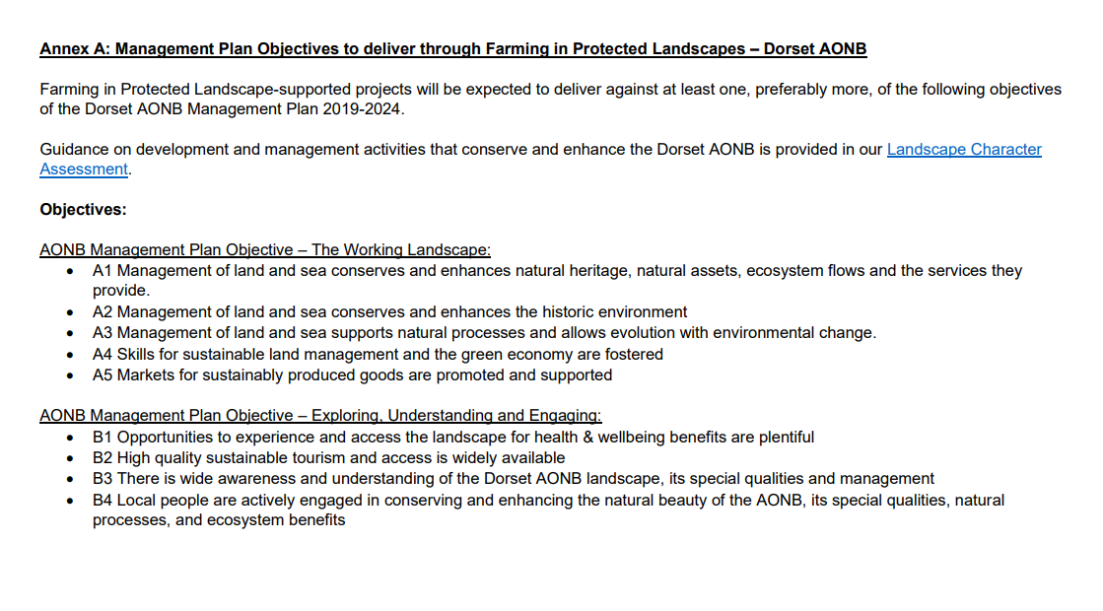
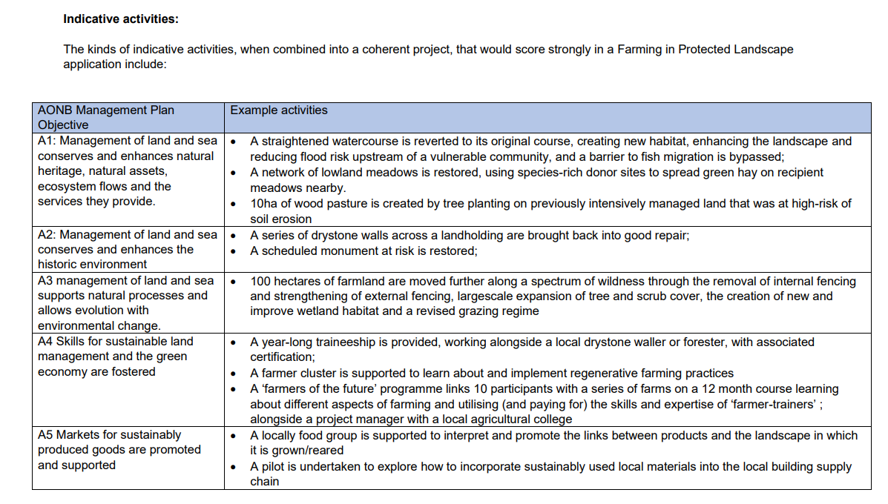
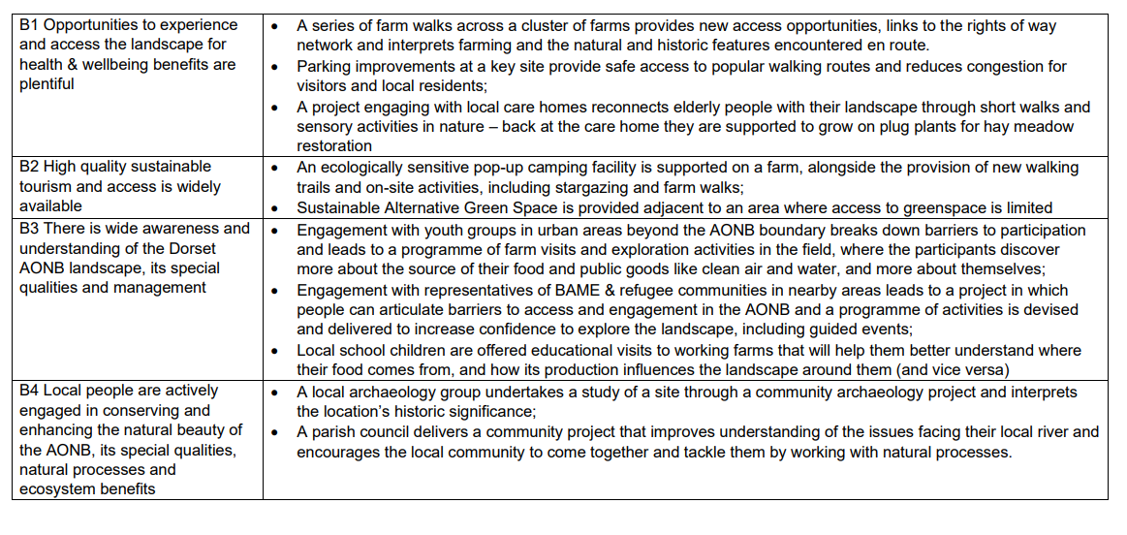

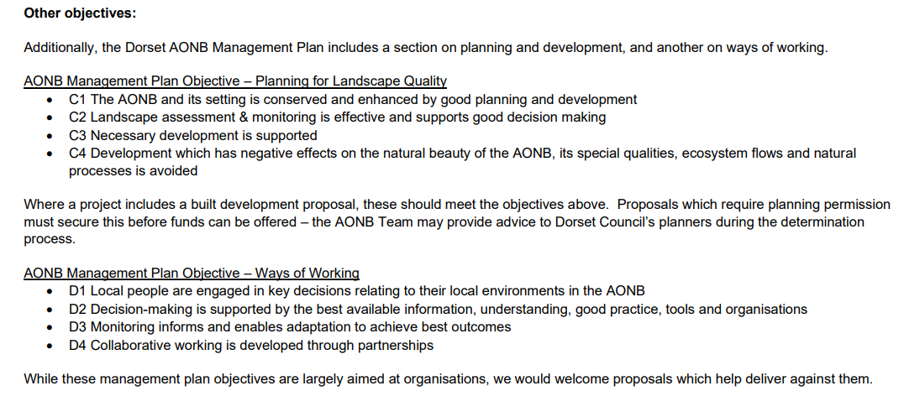
Programme outcomes
The outcomes, of which you will need to demonstrate that your project delivers against at least one, are listed below under four key themes:

Climate  - More carbon is stored and/or sequestered  - Flood risk has been reduced  - Better understanding among farmers, land managers and the public as to what different habitats and land uses can deliver for carbon storage and reduced carbon emissions  - The landscape is more resilient to climate change | Nature  - There is a greater area of wildlife rich habitat  - There is greater connectivity between habitats  - Existing habitat is better managed for biodiversity  - There is an increase in biodiversity
People  - There are more opportunities for people to explore, enjoy and understand the landscape  - There are more opportunities for more diverse audiences to explore, enjoy and understand the landscape  - There is greater public engagement in land management, for example through volunteering | Place  - The quality and character of the landscape is reinforced or enhanced  - Historic structures and features are conserved, enhanced or interpreted more effectively  - There is an increase in the resilience of nature friendly sustainable farm businesses, which in turn contributes to a more thriving local economy

What sort of projects can support ‘an increase in the resilience of nature friendly sustainable farm businesses’? | Projects brought forward under the third of the Place outcomes - There is an increase in the resilience of nature friendly sustainable farm businesses, which in turn contributes to a more thriving local economy - must deliver this in balance with and directly linked to other programme outcomes across the four themes. An activity funded and scored under this outcome cannot be the same activity that is funded or scored against one of the other outcomes – it must be additional, proportionate and supporting activity delivering against, and in balance with, at least one other outcome.  For example, machinery can only be funded where its intended use and cost proportionally supports FiPL activity, such as the cost of a seed harvester used for collecting of donor wildflower seeds will need to be proportional to the area of wildlife sites it is being spread to or the biodiversity benefits being achieved. Another example is introduction of facilities for visitors, this cost and intended purpose would need to be for supporting other FiPL activity such as bringing and enabling visitors in to experience a rewilding project or nature reserve of a proportionate value  High cost items may fail the value for money test unless they are delivering against multiple other outcomes  This outcome is not intended to support all commercial activity on farms. Business resilience and productivity measures to help businesses improve productivity, profitability, and environmental sustainability are better suited to funding through the Farming Investment Fund which provides grants towards farming equipment and technology, water management and slurry management. Additional funding support may emerge as part of development and improvements to existing offers or as new schemes.

Examples of the types of work or projects that are relevant to the outcomes of this programme could include
- Creating scrapes, ponds or other wetland to support a variety of wildlife
- Providing new or easier access opportunities, links to the Public Rights of Way network, or providing interpretation of farming, nature and heritage
- Parking improvements at a key site to provide safe access to popular walking routes and reduce congestion for visitors and for local residents
- Restoring drystone walls or hedges
- Conserving historic features on a farm, such as lime kilns or lead mining heritage
- Action to reduce carbon emissions, or the use of plastics, on a farm

What about energy generation?

Energy generation should not typically be seen as delivering an outcome within the Climate theme or as part of the FiPL programme. A project using a form of renewable energy for energy generation is only eligible for that part where it is provided solely for the purpose of contributing to a wider FiPL project activity itself. For example, you might have a small wind turbine which solely powers a classroom where students will learn about the feature. Where energy generation is supported, the renewable energy feature will need to demonstrate value for money within the project outcomes. Renewables cannot be included in a FiPL project if they have any form of feed in tariffs or are connected to the National Grid. Solar parks or solar arrays will not be eligible. Any form of energy audit included in an application must be part of a wider project delivering measurable FiPL project outcomes.
FiPL should not be used as a means of gaining other renewables incentives, for example from a third party provider or energy incentive scheme.

FiPL agreement lengths

You are required to enter a proposed project start date and end date on your application, and your agreement duration will be discussed with the Protected Landscape as part of the application process. No agreement will continue beyond the end of the programme, 31 March 2025, and all agreements and payments will end by this date.

Your onward grant agreement will set out your grant agreement expectations including your responsibilities and requirements. You will not need to maintain any natural, cultural and access activities you deliver as part of the programme after your agreement period ends.
You must maintain capital infrastructure such as fences, gates or restored buildings for 5 years from the completion date.
You must maintain machinery assets such as brush harvesters for grassland restoration for 5 years from the purchase date.

Proportionate project evaluation

Project evaluation is an important part of the design of the FiPL programme to help inform future schemes and programmes.

By applying through the FiPL programme you will be expected to participate in a proportionate project evaluation with your local Protected Landscape team and, if required, feed into programme evaluation led by an external evaluation team.

Completing Section 4: Project costs
This section focuses on the costs for your project. You should discuss your project with your FiPL officer before completing this section.
Maximum grant allowance

The maximum grant you can apply for through this programme is £100,000. However, we anticipate most projects being awarded between £500 and £25,000. If your grant request is likely to be over £50,000 then please talk to the FiPL Officer first.

Minimum grant allowance

The minimum grant you can apply for through this programme is £500.

Capital and Revenue Spend

You can apply for both capital and revenue spend. You will be required to provide a full breakdown of costs against activity on your application. Applications are financial year dependant so costs must be identified against the correct financial year in which the activity is to be completed and claimed.

Revenue spend is where funding is provided to deliver land management activity to achieve the Farming in Protected Landscape outcomes and objectives.

Capital spend is a one-off itemised cost where funding is provided to purchase or invest in a physical item or asset (capital item). Capital items can be natural landscape features (such as trees, hedgerows and ponds) or built (such as fencing, water, infrastructure, buildings, machinery and equipment).

Revenue spend is paid on an annual basis, 50% in advance and 50% in arrears. Capital spend is paid on completion of the item or activity

A capital item will be expected to proportionally support wider FiPL outcomes and activity. For example, funding of machinery must reflect and be proportionate to the area or quantity of activity and the FiPL outcomes being managed by the machinery. Fencing, for example, will be expected to support the introduction of grazing or to support FiPL land management, or items such as those to deliver water or air quality outcomes will be expected to support the wider catchment.

Environmental surveys, management plans or studies such as those for biodiversity, carbon, species or habitats may be eligible, but only where they have clear objectives and actions to deliver wider FiPL activity or longer term FiPL related objectives beyond the term of the programme.

GPS cattle collars (virtual fencing systems) may be funded in limited circumstances and for native breed at risk cattle where they are used to deliver clear FiPL and Protected Landscape conservation grazing benefits and outcomes.

Capital spend does not include items outside of the definition above, such as the purchase of livestock, vehicles (mechanised conveyance vehicles) such as Tractors, Quadbikes, Gators, ATVs, 4wd trucks, etc, or renewables where they have any form of feed in tariff or if connected to the National Grid. Second-hand machinery is not eligible. For further advice on what revenue or capital items can be applied for please speak to your Protected Landscape team.

Payment and Intervention Rates and providing quotes

The purpose of the programme is to enable additional support where it is most needed for farmers and other land managers in Protected Landscapes – and delivering for climate, nature, people, and place. As with Countryside Stewardship, some projects that achieve these ends will inevitably have a commercial dimension, and this factor is reflected accordingly in the payment rates.

You should be aware that the programme is designed to fund additional activities that deliver our programme goals in ways that are most effective for local areas. It will not provide subsidy for normal private sector interests. All applications will be rigorously reviewed to ensure there is no overlap with other programme funding or grant schemes. For any further queries on this matter, please contact your Protected Landscape team.

Where there is an equivalent Countryside Stewardship or Farming Investment Fund rate for the work or activity you want to do, that rate will also be used in the Farming in Protected Landscapes programme.

Where you are applying to fund an item or activity for which there is no equivalent standard payment rate, you will need to get quotes for the work on an actual cost basis. Normally a minimum of 3 comparative quotes are required. Your Protected landscape team can advise you on this.

Funding on an actual cost basis will be at a percentage intervention rate based on commercial gain and benefit to you. Where the project supports a clear commercial gain to you then you can be paid up to 40% of eligible costs, and if the project generates some commercial benefit to you but is primarily delivering public goods, then this could be paid up to 80% of eligible costs. Only in exceptional cases where the project has no commercial or financial benefit to you could you be paid up to 100% of the eligible costs.

The intervention rate will consider the benefit beyond the immediate or direct costs to you, for example the longer-term benefit to you or your farm, the asset value, or any wider or indirect commercial use or benefit to you or your business such as grazing benefit, operational or farm management practices. The intervention rate is an ‘up to’ percentage rate, and a lower rate may be offered due to the competitive nature of the programme and the budget available. Your Protected Landscape team will discuss the intervention rate(s) with you when you apply.

A project may consist of a range of items with equivalent schemes activity and actual cost bespoke items, specific to the project being proposed and outcomes being targeted. You may also have different payment and intervention rates for the different activities that make up your project. Funding on an actual cost basis may also be underpinned or in combination with other Countryside Stewardship equivalent options on the same land, where the option requirements do not conflict. By combining option(s) on the same area, where they do not conflict, multiple objectives can be met.

You may also want to be paid to do the work yourself rather than through a contractor. This is possible providing it is appropriate for the project and represents a reasonable rate for the job, compared against contractor quotes or benchmarked against known costs locally or standard comparative costs.

Please speak to your Farming in Protected Landscape officer for advice on payment rates and intervention rates.

Match funding
Applications with match funding may increase their value for money scoring and chances of being offered an agreement as part of the assessment process.
If you want to use third party funding you will be required to provide details including value, source(s) and terms of the third-party funding on the application form.
Applicants will be eligible to use third party funding for Farming in Protected Landscape projects as long as the source of the third party funding is not from the Exchequer.

Match funding applies to third party funding only and does not include any contribution of your own funds to the project.
If your project includes any match funding, you must describe what this is and attach details including value, terms and source(s) of match funding with your application.
The total value of the match funding should be entered in the Project costs table and the Project Funding Summary in the application template.
Payment
If you application is successful, you will be issued with an onward Grant Agreement, setting out the terms and conditions of the agreement including the Project Details, Approved Purposes and Claim Schedule.
Claims are paid by your Protected Landscape in arrears on completed and verified activity, against paid and receipted invoices if on an actual cost basis. To be eligible for payment, you must undertake the works for the Approved Purposes as described in your Onward Grant agreement. Your Protected Landscape will discuss with you as part of the application process of the commitments and verification of completed activity as part of your onward agreement.

Completing section 5: Collaborative farmer groups
This section only needs to be completed for collaborative farmer group applications.
In order to progress a collaborative group application, you will need to have or secure a partnership agreement (s) with all participants in the project’s collaborative farmer group and yourself/your organisation (the third party). You must enclose a copy of the partnership agreement (s) for the application to progress. If your group has a constitution, please email/include this with your application.

Completing section 6: Declaration and close of application

In signing the application, you will need to confirm that you have full authority and capacity to sign and submit the application and have the necessary land management control or approval to be able to fulfil the requirements of all activities applied for. In doing so, you consent to the sharing of your information provided in your application for the monitoring of the programme and to complete dual funding check processes.

Evaluation

Defra are funding an external contractor to review the effectiveness of the programme and show what Protected Landscapes bodies can deliver in partnership with farmers and land managers. Successful applicants will need to commit to participating in the programme evaluation; the input expected will be proportionate to the level of funding received.

Further information

Web: Farming in Protected Landscapes programme | Dorset National Landscape (dorset-nl.org.uk)
Phone: 01305 228256
Email: rachel.janes@dorsetcouncil.gov.uk

Making an appeal

We understand that you may be disappointed with a decision. If you would like appeal to the decision made you should make an appeal to your Protected Landscape by contacting Rachel Janes on rachel.janes@dorsetcouncil.gov.uk.

You can only query a funding decision if you think that the Protected Landscape has:
- Made a mistake with the application
- Made a processing error
- Got the law wrong

You must set out to the Protected Landscape team the reason for your appeal under one (or more) of these three criteria.

Appeals will be dealt with by your Protected Landscape team and if necessary escalated to Defra.

Scoring criteria

- The project
Projects should score highly, dependent on:
- the extent to which the project demonstrates that it is maximising the opportunity of the project to deliver outcomes across the themes of the programme
- the extent to which the project demonstrates that it will contribute towards the Protected Landscape’s management plan / priorities
- the extent to which the project demonstrates that it will deliver the outcomes of the programme:
  - For Climate
    - more carbon being stored, sequestered or both
    - reduced flood risk
    - a better understanding among farmers, land managers and the public as to what different habitats and land uses can deliver for carbon storage and reduced carbon emissions
    - a landscape that’s more resilient to climate change
  - For Nature:
    - a greater area of wildlife-rich habitat
    - greater connectivity between habitats
    - better management of existing habitats for biodiversity
    - increased biodiversity
  - For People
    - more opportunities for people to explore, enjoy and understand the landscape
    - more opportunities for diverse audiences to explore, enjoy and understand the landscape
    - greater public engagement in land management, for example through volunteering
  - For Place
    - enhancing or reinforcing the quality and character of the landscape
    - historic structures and features being conserved, enhanced or interpreted more effectively
    - an increase in the resilience of nature-friendly sustainable farm businesses, which contributes to a more thriving local economy (it must deliver this along with other outcomes)
- the extent to which the project maximises the opportunity to work with other farmers and land managers to deliver outcomes

- Ability to deliver
Projects should score highly if they:
- demonstrate clearly the resources available to enable delivery of the FiPL project to the required standard necessary to deliver the FiPL project outcomes.
- show the roles of those involved in the project, demonstrating how they will contribute to the project’s delivery
- demonstrate a clear capability to deliver the FiPL project in the timeframe required
- demonstrate that the steps taken to deliver the project are appropriate and achievable
- demonstrate how they will measure the progress of the project in meeting the intended FiPL outcomes
- Sustainability / legacy of projects
Projects should score highly if they:
- demonstrate that the project outcomes will have a lasting positive impact for the Protected Landscape and others once the programme of funding concludes
- demonstrate how the project will continue to maintain and build on the FiPL programme themes for the longer term.
- demonstrate an increase in sustainable farm business resilience

- Value for Money
A strong approach to delivering value for money should be demonstrated throughout the whole application.

Projects should only score highly if they:
- are the most cost-effective way of delivering the desired FiPL outcomes
- are able to justify the need for the bespoke purchase, where appropriate
- clearly demonstrate the project costs with evidence to support the costs (e.g., alignment to other Defra payment rates and with comparative quotes provided)
- demonstrate why FiPL is the most effective route to funding to achieve the project outcomes
- are seeking an intervention rate that is the minimum necessary to deliver the project outcomes.
- are making use of additional funding sources, such as match funding, where appropriate

‘Farmers’ - refers to both farmers and other land managers in the private, public and charity sectors.

