
Dorset National Landscape Partnership
Hosted by Dorset Council
County Hall, Dorchester DT1 1XJ

tel: 01305 228246
web: www.dorset-nl.org.uk

Dorset National Landscape Board Meeting, 10.00am, Thur 20th Nov 2025

Dorchester Cricket Club Pavilion, Sawmills Lane, DT1 2RZ
The meeting will start at 10.00 am sharp; the meeting room will be open from 0945. If you are unable to attend it would be helpful if you could send a briefed representative or an update. Please send apologies to Caroline Richards on caroline.richards@dorsetcouncil.gov.uk

AGENDA

TIME | ITEM | TITLE | Purpose
1000 | - | Chairman’s welcome, introduction & apologies
1005 | - | Minutes of the last meeting
1010 | 1 | Dorset National Landscape Management Plan 2026-2031 | Decision
1050 | 2 | Delivering the National Landscape Management Plan - team activity update featuring projects | Info
1130 | 3 | Update on proposals to bid for funds | Info
Break
1200 | 4 | Budget headlines for ’25-‘26 | Decision
1215 | 5 | Request from South West Coast Path Association to have a seat on the partnership board (no papers) | Decision
1220 | - | Partners’ 2-minute updates
 | - | Any other business
1300 | - | End of meeting

APPENDIX 1: further team activity detail

Proposed dates of next meetings:

 | Spring | Winter (TBC)
National Landscape Steering Group | 22nd April 2026 | 20th October 2026
National Landscape Partnership Board | 18th May 2026 | 26th November 2026

NB the Steering Group is a small group that sets the agenda for the Board. If you wish to have items added to the agenda for the Board, please send suggestions to Tom Munro or the Chairman before the date of the Steering Group meeting, so they may be considered for timetabling on the Board agenda.

Minutes of the Dorset National Landscape Partnership Board Meeting, 22nd May 2025 (Cricket Club Pavilion, Weymouth Avenue, Dorchester)

Board attendance:
Organisation | Representative | Status | 2024-011
Council for the Protection of Rural England | Dr Guy Dickinson | Voting member | Apologies
Country Land and Business Association | Will Bond | Voting member | Present
Dorset Association of Parish & Town Councils | Cllr Chris Turner | Voting member | Present
Dorset Council | Cllr Nick Ireland | Voting member | Present
Dorset Council | Cllr Ben Wilson | Voting member | Apologies
Dorset Council | Cllr Jane Somper | Voting member | Present
Dorset Council | Giles Nicholson | Supporting Officer | Apologies
Dorset Local Nature Partnership | Maria Clarke | Supporting Officer | Apologies
Dorset Natural History & Archaeological Society | Claire Dixon | Voting member | Present
Dorset Race Equalities Council | Jonathan Burke | Voting member | Apologies
Dorset Wildlife Trust | Imogen Davenport | Voting member | Present
Forestry Commission | Roly Boughton | Voting member | Apologies
Historic England | Sasha Chapman | Voting member | Present (online)
Independent chairman | Dr Phil Sterling | Voting member | Present
National Farmers' Union | Tim Gelfs | Voting member | Apologies
National Farmers' Union | Gemma Harvey | Supporting Officer | Apologies
Natural England | Robert Lloyd | Voting member | Apologies
Natural England | Ian Alexander | Voting member | Apologies
The National Trust | Hannah Jefferson | Voting member | Present

Dorset National Landscape Team: Tom Munro (Manager), Sally King (Visitor, Tourism & Access Manager), Julie Hammon (Nature Buddies), Caroline Richards (Project Support Officer), Sue Dampney (Culture, Communications & Learning Officer) Ian Rees (Countryside Officer), Kate Townsend (Nature Buddies), Richard Brown (Planning Officer).

Guests: Tom Clarke and Alexandra Brocklesby from the National Trust Purbeck Estate, who joined via teams.

Welcome, introductions and apologies
The Chair welcomed all to the meeting.
The Chair also recorded thanks to members of the Dorset National Landscape Team who have left since the last meeting. Pia Lindström, who supported Rachel on the FIPL project for 18 months, has returned to Norway, and recruitment for her replacement is underway.
Caroline Kelly, who managed the Wytch Farm access and landscape enhancement fund, has also left, with thanks expressed for her work.
Jill Hearing has retired after many years of dedicated work with the Dorset National Landscape team, including the landscape partnership and National Grid enhancement projects. The Chair wished her well in retirement and said that Jill would be greatly missed.
The Dorset National Landscape Team currently has several posts in recruitment.

Minutes of the last meeting and matters arising
The minutes of the meeting held in Nov. 2024 were agreed as a true record.

- Purbeck Together- Climate Action Fund Bid led by the National Trust
The Board received a presentation from Tom Clarke and Alex Brocklesby about "Purbeck Goes Wild," a multi-year initiative aiming to reconnect Purbeck’s children and young people with nature by leveraging community assets. Despite Purbeck’s natural wealth and outdoor industry, many local children remain disconnected from these resources.
A community vision, developed in June 2023 and launched at the Planet Purbeck Festival with support from 30 organisations including Dorset National Landscapes, seeks to provide all young people with meaningful nature experiences.
Key actions include mapping accessible opportunities, fostering cross-sector partnerships, and developing the Purbeck Goes Wild brand. Schools play a central role as community hubs, supported by resources such as trip packs and newsletters.
The Board acknowledged the challenge of community disconnection from green spaces and emphasised the importance of engaging young people to secure long-term support for nature recovery and a resilient Purbeck.

- Delivering the National Landscape Management Plan – annual review of team activity:
Tom Munro presented the 24 – 25 Annual Review, with highlight presentations on Farming in Protected Landscapes (FIPL) by Rachel Janes and Access for All by Sally King
RESOLUTION: The Board acknowledges significant progress towards delivering the Management Plan.

- 2024-2025 Provisional Partnership Accounts
TM presented the paper.
DEFRA and Dorset Council core contributions leveraged significant external funding.
£2.86m direct spend delivered, with an estimated total value of £4.75m for partnership projects.
Every £1 of Dorset Council funding generated £83.70 in landscape value.
The Board commended the team and partners for outstanding delivery, partnership working, and effective leveraging of resources.
RESOLUTION: The Board commends the funding leverage demonstrated by these accounts.

- Local Nature Recovery Strategy
The Local Nature Recovery Strategy (LNRS) is now out for public consultation, running until July 2025.
The Board emphasised the importance of reviewing and commenting on this key document, which will be among the first nature conservation strategies to gain formal approval from local councils later this year.
The LNRS builds on over a decade of nature recovery mapping and biodiversity action planning, representing an evolution of previous work rather than duplication.
Board members were encouraged to help promote the consultation within their networks to ensure broad engagement. Publicity materials, including videos, have been produced to support this effort. The Board also noted the benefit of operating largely within a single county and LNRS area

- 2025 – 2026 Defra funding update
The Board received an update on Defra funding which includes a significant increase in capital funding this year, aimed at supporting both "invest to save/earn" projects and the government's 30 by 30 nature recovery ambition.
While revenue funding remains flat, the capital allocation is higher, with tighter criteria focused on impactful, long-term outcomes.

Board Member Comments and Discussion:
- Members generally supported the proposed project areas, emphasising the need for a balanced portfolio of small and large projects and timely allocation to reduce staff pressure.
- There was broad agreement that, while a formal panel process (as with FIPL) is not yet established, recommendations from the that panel are trusted, and already follow an approved process.
- Concerns were raised about transparency and the risk of the fund appearing as a "closed shop" open only to partners. Members suggested that, while initial allocations might focus on partners, any remaining funds should be advertised more widely to ensure new applicants and landowners can benefit.
- The Board agreed on the importance of developing a clear, transparent process for future rounds, including the potential use of mapping data to target priority landowners and projects.
- It was noted that success in delivering this fund could lead to further allocations in future years, so robust processes and equitable distribution are essential.
RESOLUTION: Introduced by Will Bond and unanimously supported, The Board resolved that applications to this fund should be considered by the FIPL panel

- Management Plan Review
TM presented the paper. The Board considered the emerging vision and public consultation outline for the Management Plan Review. The draft vision has already received feedback from a range of partners, including Historic England, Natural England, Dorset Council, the Local Nature Partnership, Dorset Wildlife Trust, NFU, Forestry Commission, and the Local Access Forum.

Key Points and Board Comments:
- The Board generally supported the emerging vision, with some members noting that the coast could be referenced more strongly, and that access should be highlighted more explicitly.
- There was a suggestion to give woodlands a separate bullet point, recognising their broader value beyond nature, including local products, carbon sequestration, and public access. It was noted that local woodlands are often poorly managed and that this is an opportunity to raise their profile.
- Members discussed whether to specifically name-check designations such as World Heritage Sites and SSSIs. The consensus was to avoid listing specific sites to prevent the appearance of omission, but to ensure heritage and geology are well represented.
- The Board agreed to consider these comments and make amendments before the draft goes out for public consultation.
- The consultation will be hosted online by Dorset Council’s consultation team, with both quantitative (0–5 scale) and qualitative (free text) feedback invited. The Board noted that concerns about digital exclusion have lessened since the last review.
- The consultation will overlap slightly with the Local Nature Recovery Strategy (LNRS) consultation, and the communications approach will be coordinated to minimise confusion.
- The team will also promote the consultation at public events and markets in Bridport, Blandford, Corfe Castle, Yeovil, and Dorchester.
- Board members were encouraged to submit actions they would like to lead or see embedded in the plan.
RESOLUTION: The Board approved the emerging vision and the public consultation outline, with amendments to be made reflecting the discussion.

Partners’ 2- minute updates

Historic England (Sasha Chapman)
Sasha Chapman outlined her role as Inspector of Ancient Monuments for Historic England in the Southwest, supporting Natural England and the Forestry Commission with standalone capital grants (HE1 and PA2) and described how the national team assists landowners in protecting and enhancing the historic environment, including identifying at-risk barrows and supporting activities such as scrub clearance and geophysics surveys. Sasha highlighted ongoing collaboration with Dorset Wildlife Trust at Liscombe and Wild Woodbury and encouraged Board members to refer interested landowners to the Countryside Stewardship Heritage Service grant scheme.
The CSHS team supports applications to three Countryside Stewardship grants (all stand-alone Higher Tier Capital grants):
- PA2 Feasibility Study agreements (only to prepare for a HE1)
- HE1 Historic and archaeological feature protection capital item
- We can also develop applications for PA1 Implementation Plans (fixed at £1,200), which are directed to Natural England to sign off.

Dorset Wildlife Trust (Imogen Davenport)
- The new Lookout at Brownsea Island, developed in partnership with the National Trust, has opened as a state-of-the-art wildlife observatory, replacing the old hide. The facility offers panoramic, accessible views of the lagoon and aims to engage more visitors with Brownsea’s wildlife, especially birds. Board members welcomed the improved visitor experience and increased accessibility.
- The Peat Project has made significant progress, co-funded by the Wytch Farm Fund, DEFRA, and others.
- The Dorset Wild Rivers and Enclosed Beaver Project has completed its first five-year licence, with applications underway for continuation and possible wild release licences. The Dorset Beaver Management Group continues to address management and mitigation issues.
- Work is ongoing at Liscombe, with a management plan and stewardship application in development.
- Imogen expressed concern about the implications of the National Planning and Infrastructure Bill, particularly the rejection of amendments related to chalk streams.
- Water-related projects are progressing in the Upper Hook and Upper Fruit areas, in partnership with Wessex Water and local farm clusters, though some funding uncertainty remains due to an ongoing appeal.
Board comments: Members praised the Lookout’s transformation and its potential to attract and educate a broader range of visitors. They also noted the importance of ongoing collaboration on river and beaver projects and expressed shared concerns about the legislative changes affecting nature recovery.

National Trust (Hannah Jefferson)
- Coastal Adaptation: Projects at Hive Beach and in Purbeck are underway, focusing on adaptation and retreat strategies, though outcomes will take time to materialise. Work with project managers continues, and future infrastructure provision is being considered. A potential new acquisition is still pending.
- Tourism: The season has started exceptionally well, with visitor numbers higher than expected, bringing a welcome boost to tourism providers after a challenging few years. Museums, however, continue to face difficulties.
- Volunteer-led Walks: A new guided walks programme in West Dorset, led by 20 recruited volunteers, has been very successful, with most walks fully booked and taking place in new locations such as Lyme Regis.
- Nature Buddies & Climate Empowerment: The Trust is integrating the Nature Buddies initiative with the walks programme and continuing climate empowerment sessions with schools, supported by increased funding. These efforts help young people understand their role in local and national climate action.
- Well City Programme: Early discussions are underway to bring the successful NHS Well City programme from Salisbury to Dorset.
- Museums & Collections: The Dorset Museums Association is expected to be reformed, which will strengthen local museum networks and collaboration. There is also a new project in development to pilot a Jurassic Coast Collection, aiming to improve understanding, promotion, and access to local heritage.
Board Comments: Members welcomed the positive tourism trends and the success of the volunteer programme. The integration of climate and wellbeing initiatives was praised, as was the renewed focus on collaboration among Dorset’s museums.

Dorset Natural History & Archaeological Society (Claire Dixon)
- Claire reported that the Dorset Museums Association, previously defunct, is expected to be reformed, which will help reconnect the network of Dorset museums and strengthen partnership and collaboration.
- A joint project with Jurassic Coast Collections is being developed to secure funding for a pilot that will improve understanding, promotion, and access to the region’s heritage.
- The recent "Gladiators" exhibition was a success, resulting in an operational surplus, the first since 2010 although this was due to several one-off factors.
- New partnerships with English Heritage have enabled walks at Maiden Castle and in Roman Dorchester, with new signage welcoming visitors to the historic town. There are plans to extend this signage to car parks and bus stops to enhance the sense of arrival and promote free access to heritage.
- The museum is preparing for a new exhibition, "Jane Austen and the Sea," which will explore themes of well-being and contemporary connections to swimming and the sea. Dorset Museum has achieved LWEP status, providing a direct link to Visit England and enhancing communication and tourism opportunities.
- Claire encouraged board members to contribute articles on natural history and landscape topics to the museum’s long-standing, peer-reviewed journal, noting that submissions are currently dominated by archaeology. Board members agreed on the value of the publication as a local scientific archive and its importance for sharing research and projects more widely.

Dorset Council (Cllr Nick Ireland)
Nick Ireland provided an update covering several key areas:
- Jurassic Coast Trust: With the demise of the Trust, there is an opportunity to do things differently and make a positive impact.
- High Angle Battery Project: Highlighted as a successful initiative, with Bridget Betts’ team stepping in during her absence.
- Council Structure: Nick is working to better integrate climate, nature, and green space work within the council, aiming for improved collaboration and budgeting across these areas. He noted that climate initiatives often receive more funding and attention than nature and green space.
- Green Space Initiatives: Ongoing work includes glyphosate trials and a push for river charges to support environmental management.
- Nutrient Neutrality & BNG: Nutrient neutrality and biodiversity net gain requirements are impacting planning, particularly for pop-up campsites and new developments. New rules mean that even short-term campsites now need special permission, often requiring costly nutrient credits. Recent hotel development in Dorchester faced significant hurdles due to these requirements but has now received approval.
- Local Plan: The council is preparing for a major consultation on the Local Plan, aiming for much higher public engagement than previously (targeting 50,000 responses). Nick encouraged everyone to participate and promote the consultation.
- Public Health: Nick and board members discussed the importance of integrating public health with nature recovery and access work. Although Public Health Dorset no longer exists in its previous form, there is interest in involving public health representatives in board activities, given the strong links between access to nature and health outcomes. The upcoming NHS 10-year health plan and a shift towards prevention present further opportunities for collaboration.
- Board Comments: Members agreed on the value of integrating public health into landscape work and supported exploring ways to formalise this relationship, recognising the potential for significant health and environmental benefits if prevention is prioritised in future funding, and supporting further collaboration and innovation in these areas.

Local Nature Partnership & Country Land & Business Association (Will Bond)
- LNP Chair Vacancy: The LNP is still seeking a new chair following Luke Rake’s departure, and Will encouraged board members to suggest suitable candidates, noting a lack of responses so far.
- Conference: The recent Local Nature Partnership conference was considered successful, focusing on food, farming, and nature-based themes.
- Agriculture and Land Management: Will highlighted ongoing uncertainty in the sector, particularly due to changes in government schemes like SFI, which was withdrawn and then reinstated, creating confusion for farmers. He noted that while the US-UK negotiations could have been worse for Dorset farmers, the overall environment remains challenging.
- Nature Recovery Projects: On a positive note, several local nature recovery projects are in development, including the Wareham Arc, with others in the pipeline. These projects are progressing through phased development and, if approved by DEFRA, could secure 30 years of funding and provide long-term certainty for land management in the area.
- Board members acknowledged the challenges of uncertainty and short-term funding in agriculture, agreeing that securing long-term plans and funding would be transformative for the sector. They thanked Will for sharing these insights and emphasised the importance of continued collaboration and information sharing across the industry.
- Will concluded that, while the sector faces significant risks and uncertainty until at least 2026, the potential for large-scale, long-term nature recovery planning is a major opportunity if secured.

Natural England (David Charman)
David updated the Board on several key points:
- Budget Uncertainty and Staffing: Natural England faces significant financial uncertainty, with budget details often arriving late in the financial year. This has led to a planned 10% reduction in headcount—about 300 staff, partly due to short-term funding cycles and changes in leadership. Board members noted the challenges this creates for business planning and staff morale.
- Strategic Direction: Natural England published its new strategic direction in April, outlining priorities for growth, health, and security from 2025 to 2030. The strategy emphasises the need for a step-change in nature recovery, stronger partnerships, and a focus on places where the greatest impact can be achieved. The full strategy will be released later in the year.
- Agri-Environment Schemes: There is ongoing uncertainty over the launch of Countryside Stewardship Higher Tier and SFI schemes, with announcements repeatedly delayed. Farmers and land managers are still waiting for updates on payment uplifts and capital grants, which are unlikely to return until the next financial year.
- Project Delivery: On a positive note, the extension to Hockley National Nature Reserve has been completed, with 100 acres of new land now accessible and infrastructure in place. The reserve, located near a village with an active railway, is one of the few easily accessible National Nature Reserves and will eventually offer open access. Work is ongoing with the local community land trust to enhance the site.
- Board members acknowledged the difficulties caused by funding and staffing uncertainty but welcomed the progress at Hockley NNR and the focus on community access and long-term planning. They agreed that long-term, stable funding and strategic direction are crucial for effective nature recovery and partnership working.

Any other business
- None.

The next regular board meetings are on Thursday the 20th of November and the 18th of May 2026.
The Meeting closed at 13:15

DORSET NATIONAL LANDSCAPE MANAGEMENT PLAN 2026-2031
ITEM FOR | Decision | REPORT BY | Dorset National Landscape team
SUMMARY | The board approved a draft for public consultation in June 2025.  A public consultation was held from July-September 2025.  Over 140 respondents provided comments, including a majority of Partnership Board organisations.  The draft has been amended in response to those comments received and is presented for the Board’s approval for adoption. Any further amendments required need to be agreed at this meeting.
FINANCIAL IMPLICATIONS | Consultation and engagement costs have been borne by using core reserves
RECOMMENDATION | The Board recommends this plan for adoption by partners

  - Consultation process
The public consultation was questionnaire-based, hosted on the Dorset Council consultation platform and open for responses from 14-07-25 to 22-09-25.
Paper versions of the survey were available to aid accessibility, available by request. They were also made available at 14 libraries in and around the National Landscape with paper copies of the draft Management Plan for reference.

  - Engagement
The Dorset National Landscape team promoted the consultation at several public events chosen to reach a diverse audience throughout the consultation period.
Date | Event | Number of engagements
30-Jul | Bridport Wednesday market | 29
07-Aug | Blandford Thursday market | 18
09-Aug | One World Festival, Dorchester | 24
06-Sep | Consequences unfurling event, Cerne Abbas | 18
13 & 14 Sep | Consequences community parade, Yeovil | 16
20-Sep | Planet Purbeck Discovery Fest | 39
20 & 21 Sep | Inside Out Dorset at Corfe Castle | 129

It was promoted to delivery partners at:
- Dorset Catchment Partnership delivery group meetings
- Dorset Local Nature Partnership board meeting
- Wild Purbeck Partnership meetings
- Purbeck Heaths National Nature Reserve steering group
- Cultural Officers’ group

And there was an accompanying e-media programme:
- Social media posts 2-weekly for most of the consultation period then weekly in last month;
- Dorset Council e-news at the beginning of campaign (c30,000 subscribers)
- Dorset National Landscape e-news in early September (15,000 subscribers)

Alongside the formal consultation, the team also ran an engagement exercise at the public events listed called ‘Postcards from the Future’ in recognition that the Management Plan is wordy and not necessarily accessible to all people. The intention was to encourage people to contribute their thoughts in a different way. This idea was developed on one pioneered in Surrey Hills National Landscape last year.
Postcards From the Future ran at all the public events attended during the consultation period. People were be asked to write, draw or dictate a postcard from the future about how the landscape looks and feels to them.
The team had certain prompts where people needed help to form some content.:
- What do you love now and would like to see thrive in the future? (eg favourite tree, view, butterfly)
- Is there something you love in the landscape that you fear may not survive into the future?
- What don’t you have now that you would like to see in the future? (eg cycleway to work, bus service, nature reserve)
- What three words come to mind when thinking about future landscape?
Or more simple prompts:
- What is special about this place for you?
- What would you like more of there?
- What would you like less of?
114 postcards were collated at the end of the consultation and are being used to inspire a piece of writing by local writer and poet Louisa Adjoa Parker which will be included in the Management Plan.

  - Consultation respondents
Breakdown of respondents is as follows:
Respondent type | In-format response | Out-of-format response | TOTAL
Business | 5 | 5 | 10
Public | 94 | 7 | 101
Organisation | 15 | 6 | 21
Town/Parish Councils | 5 |  | 3
Other | 3 |  | 5
TOTAL | 122 | 18 | 140

Businesses: 8 farms, 1 holiday let & 1 unidentified.
Organisations: Evolving Forests Ltd, Dorset CPRE, Swanage Town Council, Active Dorset, Natural England - West Dorset, Dorset, Bournemouth, Christchurch & Poole Joint Local Access Forum, Dorset Wildlife Trust, Wareham Town Trust, Jurassic Coast World Heritage Site, Dorset Local Nature Partnership, Dorset Race Equality Council, Wessex Water, The Ramblers (Dorset Area), The National Trust, Lyme Regis Town Council, Wimborne Minster Town Council, Arne Parish Council, Dorset Council, Wareham Town Council, Bridport Town Council, Historic England, Activate Performing Arts, Natural England - health & environment SW, Wareham Neighbourhood Plan SG, NFU, Dorset Climate Action Network.

- 77.1% (94) of responses were from members of the public, 12.3% (15) on behalf of an organisation, 4.1% (5) from both businesses and Town or Parish Councils and 2.5% (3) identified as ‘Other’.
- 50.0% of respondents were female, compared to 39.3% that were male.
- 59.3% (67) of respondents were aged over 60. 25.7% (29) were aged between 40 to 59, and 5.3% (6) were 39 or below.
- 7.3% (8) of respondents identified as having a disability and 90.7% (97) identified as White: British.

  - Consultation responses
The full record of consultation responses has been shared with the National Landscape Steering Group, and is available on request.
- Vision
- 84.2% agreed or strongly agreed with the vision
- Understanding of the Plan
- 89.3% understood the purpose of the Management Plan

Chapter-by-Chapter Feedback
- National Landscapes
- Describes the geography of the Dorset National Landscape was best understood with 78.7% saying it met its intended purpose ‘completely’ or ‘to a great extent’
- Partnership working beyond boundaries was least clear, with 59.5% saying it met its intended purpose ‘completely’ or ‘to a great extent’
- The Management Plan
- Both ‘What’ and ‘Who’ the plan is for received the most positive feedback, with 65.6% and 64.6% saying these sections met their purpose ‘completely’ or ‘to a great extent’ respectively
- Relation to other plans and impact of previous plans received more mixed feedback, though feedback was still generally positive
- The Operating Environment
- 62.5% agreed or strongly agreed with the rationale for change.
- Some uncertainty and disagreement noted.
- The Working Landscape
- All the objectives received strong support, with a minimum of 70% agreement across them all. The 2 with the highest agreement rates were:
  - Conserving and enhancing nature: 85.9% agreed or strongly agreed
  - Conserving and enhancing historic landscapes: 84.1% agreed or strongly agreed
- Exploring, Understanding, Engaging
- As with the previous chapter, all the objectives received high levels of support, in particular:
  - Engaging local people in landscape stewardship: 83.5% agreed or strongly agreed
  - Enabling enjoyment and access for wellbeing: 80.9% agreed or strongly agreed
- Planning for Landscape Quality
- Most mixed feedback of all chapters
- Strongest support for avoiding harmful development (82.7%). Necessary and sustainable development had the lowest agreement rate at 62.7%
- Ways of Working
- High support for:
  - Engaging people in key decisions relating to the national landscape: 84.1% agreed or strongly agreed
  - Informing decisions with high quality evidence and best practices: 82.8% agreed or strongly agreed
  - Monitoring and adapting to achieve optimal outcomes: 80.1% agreed or strongly agreed
  - Developing collaborative working through partnerships: 76.9% agreed or strongly agreed

- Delivery Priorities
- Area-Based
- Highest support for ‘Landscape enhancements across the Wild Purbeck Nature Improvement Area’ (75.2% agreed or strongly agreed)
- ‘Visitor management and visitor experience enhancement across the Jurassic Coast…’ and ‘A landscape-scale project conserving natural and cultural landscape heritage…’ also well supported at 71.0% respectively
- Landscape enhancements in the National Grid high voltage electricity transmission corridor had the lowest agreement at 57.8%
- Thematic
- Promotion of local food and drink: 78.9% agreed
- Connecting people with nature: 73.1% agreed
- Agri-environment support: 73.7% agreed

- Informed levels
- 82.5% indicated they felt at least moderately informed about the draft plan

  - Amendments to the draft plan
Change log:
SECTION | CHANGE | RECOMMENDED BY
Vision | Nature: re-wording re water | Wessex Water
 | Climate change: is this ambition over-reach for the DNL Partnership? | Several respondents (public + DCAN)
 | Food: include fishing  NFU recommended a definition of regenerative ag – this has been added to 7.1 | NE, DC  NFU
 | Heritage: protection added | HE
 | Access: ‘freely’ was queried as it may imply ‘without charge’  Special qualities also added (to include dark night skies, etc) | DLNP  Public
 | Health & wellbeing: ‘for all’ added to enhance inclusion | Active Dorset
Minister’s Foreword | Several respondents queried why it should have a ministerial foreword. | Public, business
 | Postcards for the future poem added | This was commissioned as part of the engagement process
1 Introduction | Reference to food production added | NFU
2 National Landscapes | 2.1 clarification around LURA (& date typo) | Public
 | 2.2 emboldening the gov guidance quote | NE
 | 2.2 cross-reference chapter 5 | Arne PC & public
3 This Mgt Plan | 3.3 addition of a wider range of biodiversity & water initiatives | WW & public
 | 3.3 Local plan clarification | Public
 | 3.3 river basin management plans | WW
 | 3.3 cultural strategies | Activate
 | 3.4 Nature Calling: reference APA | Activate
4 Op Env | 4.1.1 assuming LNRS will be adopted when this plan is
 | 4.1.1 add mention of more regional clustering for health | DLNP
 | 4.2.1 N&C emergency: several respondents ask us to spell out the scale of the issue. This could be done by linking the ‘State of’ report. | Public
 | 4.2.1 add reference to heritage features | HE
 | 4.3.3 addition made in response to the EqIA process | EqIA
 | 4.3.6 addition ref polarisation of attitudes | DWT
5 St of Signif | 5.1.1 dynamism | JCWHS
 | 5.1.1 perceptual qualities | DC
 | 5.2.1 water enrichment addition | DCAN
 | 5.3 WHS’s two facets of Outstanding Universal Value (History of Planet Earth and the Evolution of Life, and Coastal Systems – the latter being under-represented, underlining this site’s importance. | JCWHS
 | 5.4.1 PJ Harvey addition. Discuss: Elizabeth Frink | Activate
6 LCA & LSCA | Request for more reference locations on the maps – while inappropriate at this scale, the online version will point towards Dorset Explorer’s interactive mapping | Public
 | Challenge to Purbeck Plateau being Dorset’s only Limestone Plateau – amendments made to clarify ‘in the DNL’ | Public
7 The Working Lscape
 | 7.1.1 lscape & landform: food production added | NFU
 | 7.1.2 opps: insertion of regen ag definition | NFU
 | 7.1.2 opps: County Farms addition | Bridport TC
 | 7.1.2 opps: insert ethical wrt green finance | Public
 | 7.1.2 pressures: amendments to climate change section | DWT (& others)
 | 7.1.2 pressures: for discussion – ‘wildfire’ (which might imply no human origin) or simply ‘fire’? | DWT
 | 7.1.2 pressures: heritage assets added to climate change | HE
 | 7.1.2 pressures: shifting political priorities reworded to be less scheme-specific (and more enduring) | DWT
 | 7.1.2 pressures: re-worded ‘nature loss’ bullet for increased emphasis | DCAN & WW
 | 7.1.2 pressures: access to work added | Public
OBJECTIVE A1 | Former A6 becomes A1e: ‘nature’ includes geodiversity | JCWHS (& public)
 | A1a: reference LNRS | DC
 | A1b: carbon addition in response to SEA | SEA process
 | A1d: reference LNRS | DC
 | A1d: include right tree, right place | SEA process
 | A1e: include dynamism | SEA process
OBJECTIVE A2 | Objective statement broadened to include setting | SEA process
 | A2a reference unavoidable loss | SEA process
OBJECTIVE A3 | A3a inclusion of stormwater management etc | WW
OBJECTIVE A4 | Objective statement amended for tighter alignment with statutory purpose | Public
 | A4b new policy to include heritage skills | HE
OBJECTIVE A5 | A5a reworded | SEA process
OBJECTIVE A6 | Geodiversity objective included in A1 as an intrinsic part of nature | JCWHS
7.2 Exploring, Understanding, Engaging
Intro text | Amended to strengthen equality objectives | DREC, NT
7.2.2 opps | Reference green & blue spaces | Business
 | Reference good practice projects | DREC
 | Include emotional connection | SEA process
 | Reference social media | JCWHS
 | Reference NLA / ACE MoU | Activate
 | Codes of conduct | NFU, JCWHS
 | ROWIP; NNR | DC, NE
 | Communities close to the NL | DREC
7.2.2 pressures | Car ownership | Public
 | Reference open access islands | Dorset LAF, Ramblers
 | Instagram tourism | JCWHS
7.2.3 orgs | Some reorganisation and additions | Several
OBJECTIVE B1 | B1a new supporting action – address barriers | NT
 | B1a ‘enabling people’ change | DREC
 | B1a insert co-creation | DREC
OBJECTIVE B2 | New supporting action (outdoor activities / nature-based tourism) | NT
 | B2a ‘considerate use’ | NFU
OBJECTIVE B4 | Insert cultural heritage | HE
 | Insert reciprocity | Public
 | B4a include young people | NT
 | B4a: more specific about underserved communities | NT
 | B4a broaden opportunities for engagement | NT
7.3 Planning for Landscape Quality
7.3.1 | Wildlife: include avoidance | DWT
 | Cultural legacy: broaden definition | HE
OBJECTIVE C1 | Addition re character & beauty, best & most versatile land etc | NFU
 | C1a mitigation hierarchy addition | DWT
OBJECTIVE C3 | Objective text: sensitive design | DC
 | C3a strengthen farm diversification action | NFU
 | C3a two new supporting actions enabling support for nature recovery support and other projects with positive environmental outcomes | DWT, WW
 | C3c inclusion of offsite & onsite measures | DLNP, DWT
 | C3c inclusion of support for green/blue infrastructure | DC
OBJECTIVE C4 | Objective text: include WHS | JCWHS, DLNP
 | C4a new supporting action re WHS | JCWHS
 | C4b reworded to include net gain, and ensuring such measures are consistent with designation purpose | DWT
 | C4c new supporting action re protection | Farm
 | C4c broadened | DC
7.4 Ways of working
7.4.3 orgs | Include community environmental organisations | DCAN
D1a & b | Change ‘promote’ to ‘support’ to be more proactive | SEA process
D2a | Include LNRS | DC
8 Delivery
 | 8.1.1 Clearer priority themes (several respondents asking for clearer commitment on delivery); low support score for LEI/National Grid corridor work.

  - What happens next?
Once formally agreed by the Partnership Board, this version will be put forward for formal adoption. Dorset Council’s Cabinet is to consider it on the 9th December. All Partnership Board organisations are also encouraged to adopt it.

DELIVERING THE DORSET NATIONAL LANDSCAPE MANAGEMENT PLAN: MID-YEAR REPORT
ITEM FOR | Information | REPORT BY | Dorset National Landscape team
SUMMARY | The National Landscape team is leading, coordinating, promoting and supporting delivery of the actions and intent of the National Landscape Management Plan as the central part of its core duties and through specific projects.
FINANCIAL IMPLICATIONS | Delivery based on agreed budget and business plan.
RECOMMENDATION | The Board approves and notes the progress made towards delivering the Management Plan 2019-2024
Further detail is appended to the rear of these papers.

NATURE
The National Landscape’s wealth of wildlife is one of the outstanding qualities that underpin its designation, including the extent and diversity of semi-natural habitats and the wide array of species. The UK’s most diverse grid square (vascular plants and mammals) is in the Dorset National Landscape to the south and west of Wareham.
The National Landscape team leads strategic nature-focussed partnerships in Wild Purbeck and the Dorset Downs and Vales Conservation Forum, and contributes to many others (SNCI Forum, Jurassic Coast Nature Recovery Network, Dorset Local Nature Recovery group, Dorset Local Nature Partnership, etc).
The Partnership also directs significant funding towards nature outcomes through Farming in Protected Landscapes (FIPL), the Wytch Farm Landscape and Access Enhancement Fund and other ad hoc funding streams.

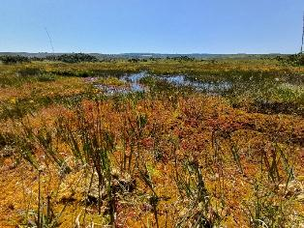 | 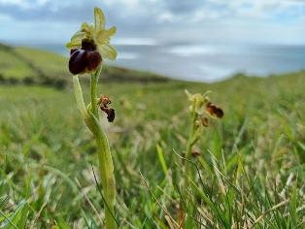

PURBECK HEATHS ‘SUPER’ NATIONAL NATURE RESERVE (NNR)
Dorset National Landscape Team Manager chairs the Purbeck Heaths NNR Steering Group and the Wilder Grazing Unit Working Group. These groups bring together the landowning bodies to oversee and implement delivery of the NNR Management Plan and the specific objectives of the wilder grazing unit. A key principle across the heaths is to reinstate natural processes at this landscape scale, alongside enhancing people’s engagement and opportunities to connect with nature. The following working groups report to the steering group:
- People & Engagement, developing a joint visitor management strategy and an ambitious engagement strategy
- Monitoring & Research, including the development and support of the independent Purbeck Natural History Forum which enables and supports ecological monitoring volunteering across the seven land holdings making up the NNR and into the surrounding area.

Highlights:
- This year the Purbeck Heaths NNR team has received delegations from Northumberland, Hampshire and Cornwall, all seeking to learn from the local experience in their endeavours to re-wild and develop further super NNRs.
- Forestry England commissioned a study looking into the issues and opportunities of introducing bison to this landscape, primarily in their potential role to manage scrub and regrowth of trees as an obligate browser (ie will target scrub and trees first for forage).
- A new Dorset Open Spaces Public Spaces Protection Order was introduced in July, superseding the 2022 Order and including a significantly enlarged number high nature value heathland sites vulnerable to wildfire, including all of the Purbeck Heaths NNR (whereas it was only partially covered by the 2022 Order). The Order prohibits activities which have a high likelihood of causing heath/woodland fires (e.g. fires, barbeques, fireworks and Chinese lanterns).
The partners’ commitment to the restoration of natural processes at scale, and the innovations in monitoring and research are seen as a national exemplar. The Purbeck Heaths NNR is a frequently visited site by others seeking to adopt similar approaches in other parts of the country.

WEST DORSET RIVERS & COASTAL STREAMS
The Dorset National Landscape is the catchment host for the West Dorset Rivers and Coastal Streams operational catchment, and supports action to improve the condition of our rivers and streams, guided by issues appraisals that are updated every five years.
Two communities have been particularly motivated to improve their rivers: those along the River Asker, and those along the River Char, and we are expanding our efforts to the communities along the Swan Brook too, in partnership with Swanage Town Council, Planet Purbeck, and the National Trust. Through partnership working with Dorset Wild Rivers, we have supported landowner advice, improved land management, habitat management, river restoration, and invasive species control. We also support the community-led ‘Clean Rivers of West Dorset’ group.
A focus over the past 18 months has been on the wider River Brit Catchment, which includes the Simene, Mangerton and Asker as well as the Brit. We have led a successful bid to the Environment Agency for a Natural Flood Management Project. At the same time, West Dorset Wilding have successful secured funding from Defra for the Brit Catchment Recovery Project.
Highlights:
- Successfully delivered Phase 1 of the Brit Catchment Natural Flood Management project, including securing landowner permissions for the 35 sites and installing 27 river level monitors.
- Having completed Phase 1, we have moved into Phase 2; delivery of measures. Works completed to date include 1.8ha of floodplain connection at three sites, 2 offline ponds that will intercept floodwater before it reaches the River Brit, 1.5km of leaky dams, and three hectares of land use change.
- We are working in partnership with West Dorset Wilding to mobilise volunteers to help undertake the required monitoring. So far we have trained 17 volunteers, and are embarking on the first round of visits.
- Completed five years of delivery as part of Dorset Wild Rivers, in partnership with Dorset Wildlife Trust and Farming and Wildlife Advisory Group South West. The combined efforts over the five years are set out in the appendix.
- Secured a further five years of funding from Wessex Water to enable the continuation of the Dorset Wild Rivers Partnership, now expanded to include the National Trust. This is for £25,000 per annum.
- The Landscape Lab is now in place, and we are working with Pineapple Estate to roll out this community facility.
- We are a partner in the Swanage Streams Partnership, which is taking a community-led approach to tackling issues on the Swan Brook and other local streams. Other partners are Planet Purbeck, National Trust, and Swanage Town Council.
- With Blackdown Hills National Landscape and East Devon National Landscape, we have been successful with a bid to the National Lottery Heritage Fund to develop a project focussed on improving the health of the River Axe, and engaging communities about the river’s special qualities. The project is a called ‘Rivers Run Through Us’. The development grant is for £250,000, and upon successful completion will unlock a further £1.2M. The development phase is two years.
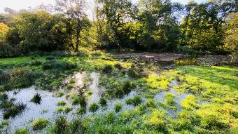 | 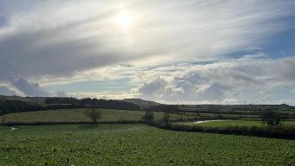
Two recently connected floodplains, one on the River Brit and the other on the River Asker, pushing the water along historical courses and slowing the speed in which is moves downstream. The cumulative impact over time will be a reduction in peak flood levels in Bridport.
www.dorset-nl.org.uk/project/rivers

WYTCH FARM LANDSCAPE AND ACCESS ENHANCEMENT FUND
WFLEF Projects –there have been a total of 38 successful project applications, 29 of these have been completed and there are 9 live offers including Beavers, Beryl bikes, Veteran trees, peatland restoration, non-native species control, car-free access and surface improvements to access routes. The fund is effectively committed so we are not seeking new expressions of interest. The priority is to monitor and encourage progress on the remaining live projects.

See 5 project case studies on the National Landscape website Wytch Farm Landscape and Access Enhancement Fund | Dorset National Landscape

LANDSCAPE ENHANCEMENT INITIATIVE
National Grid, through their Landscape Enhancement Initiative, have supported three projects in the Dorset NATIONAL LANDSCAPE that enhance landscape around their infrastructure. These are focussed in and around the Marshwood Vale and along the South Dorset Ridgeway, and consist of meadow restoration, dry stone wall restoration, hedgerow planting and management, river restoration, and other beneficial activities that deliver management guidelines set out in our Landscape Character Assessment.

Two projects have completed delivery, with one – Linking Chalk, River & Vale – still ongoing. The projects are delivered in partnership with local farmers and landowners, Dorset Wildlife Trust, Farming and Wildlife Advisory Group South West and the National Trust. In total we have secured £600,000 of investment from the National Grid, matched by £300,000 of in-kind support, resulting in £1M of investment in the protected landscape since 2018.

Linking Chalk, River & Vale outputs delivered to date:
- 135m dry stone wall restored
- 3 ponds restored
- 2.8ha scrub managed to support grassland restoration
- 0.35ha wildlife corridor enhanced for nature

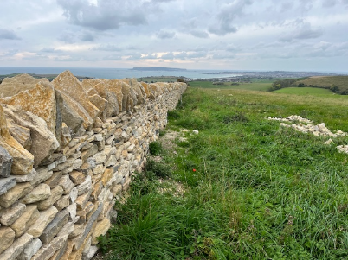 | 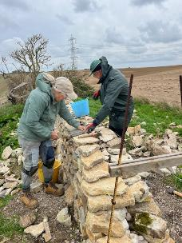

Dry Stone Wall Association volunteers at Donkey Down October 18th 2025

Investment through the LEI has allowed us to deliver significant landscape enhancement in the Dorset NATIONAL LANDSCAPE, and we hope to apply for further funding from the National Grid in the future to continue this good work.
Reconnecting the Landscape | Dorset National Landscape

SOUTH PURBECK POTENTIAL NATIONAL NATURE RESERVE
The National Landscape team is convening parties interested in creating a new ‘super’ NNR effectively extending Durlston NNR to the west along the coast to near St Aldhelm’s Head. Landowners are Dorset Council, Swanage Town Council, Dorset Wildlife Trust and the National Trust. There is the potential for neighbouring landowners to dedicate land either for full inclusion (in which case the land needs to be under a long-term commitment to be managed primarily for nature) or in a supporting, affiliate role.
A marine element has been explored: while the inshore waters are a very important part of the coastal ecosystem here, its inclusion is unlikely to be successful. However, the land-sea interactions are an important part of this site’s narrative.
While this site is not on Natural England’s list of forthcoming declarations, an opportunity has opened as another site in East Anglia is likely to drop out. If this does take that slot, declaration could be in Nov/Dec ’26.
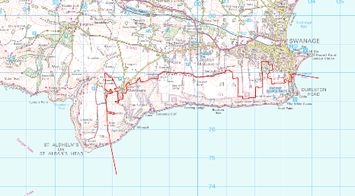
Indicative map only: this is not a definitive boundary but illustrates the likely extent.
© Crown copyright and database rights 2025 OS AC0000830671.

DORSET NATIONAL LANDSCAPE CAPITAL FUND
The Partnership received £375,717 CDEL (capital) funding from Defra this financial year which can be spent on two purposes:
- Invest to save: capital investments that lead to earned income or the deferment of revenue expenditure
- 30 x 30: capital expenditure on projects which further the government’s 30 x 30 ambition (to have 30% of the country managed for nature by 2030)
With no lead-in and no accompanying RDEL (revenue funds) to enable delivery, it has been difficult to generate a pipeline of projects, but the funds are now fully committed as follows:
Agreement holder | Description | £ offered
DNL team | INVEST TO SAVE: fingerpost project investment in patterns with Bridport Foundry to enable cheaper repair products; investment in materials to save any revenue spend on this project. | £16,000.00
Dorset Wildlife Trust | 30 x 30: funds to support the purchase of a Rytec cut & collect flail to enable meadow restoration. This dovetails with FIPL investment in a seed harvester to enable the creation of new wildflower meadows. | £23,622.56
RSPB | 30 x 30: an innovative research & development project studying soil macroinvertebrates for habitat suitability for ground-probing birds, most notably the Chough. | £4,995.00
Dorset Peat Partnership | 30 x 30: further work on the Agglestone and Greenlands mire systems, stabilising peat loss and re-wetting to encourage greater peat formation. | £36,971.98
Magdalen Farm | 30 x 30: a wide-ranging package of support creating new habitats including wood pasture | £43,492.00
Urban Heaths Partnership | 30 x 30: a contribution towards signage costs that were required as a result of the expanded PSPO | £5,830.10
Ewens Farm | 30 x 30: small-scale wildflower meadow creation | £768.00
Landlord’s Knapp | 30 x 30: small-scale wildflower meadow creation | £610.00
Mosterton Parish Council / Ecologic | 30 x 30: river restoration where the River Axe crosses Mosterton Village Green – extending work that has been supported by both FIPL and the Environment Agency. | £3,027.24
Middlebere Farm | 30 x 30: enabling tree planting to create new wood pasture on the Middlebere peninsula, adjacent to the Purbeck Heaths | £9,000.00
National Trust | 30 x 30: a contribution towards the planned purchase of 25ha arable field adjacent to the Giant Hill SSSI, Cerne Abbas, to create new chalk downland, scrub and wood pasture habitats. | £231,400.00
TOTAL |  | £375,717.27

NATURE RECOVERY PLANNING – local and national
Production of a Nature Recovery Plan is part of our Colchester Declaration commitment. Every National Landscape in England is committed to producing a plan that will set out the important areas for wildlife and opportunities for enhancing the landscape for them.
The Dorset National Landscape has developed a process through its draft Nature Recovery Plan that has been refined and incorporated into the Dorset Local Nature Recovery Strategy, ensuring that our ambitions are aligned with this important new piece of guidance.
We are also required to produce Climate Change Adaptation Plans as part of the Protected Landscapes Targeting and Outcomes Framework and Third national Adaptation Programme. We are embarking on this process with the support of Dorset Council.
Highlights:
- Representing Dorset National Landscape on the National Landscapes Association Climate and Nature Panel.
- Supporting Dorset Council’s production of the Local Nature Recovery Strategy by chairing the data and mapping expert advisory group and sitting on the land use group and overall steering group.

CLIMATE
The NATIONAL LANDSCAPE Partnership has recognised the need to reduce emissions from this landscape, enhance carbon sequestration and storage and adapting the landscape and our activities to enhance resilience in the face of a changing climate. In addition, we recognise in both policy and practice the need for additional renewable energy generation, and support applications which are of the right scale and materials for their location. One of the major opportunities for this landscape is to harness natural solutions which store and sequester carbon as well as absorb water and mitigate extreme heat events.
The NATIONAL LANDSCAPE team has also provided input to the Dorset Council Climate & Ecological Emergency Action Plan – the plan and reported actions can be found on the Dorset Council website

FARMING IN PROTECTED LANDSCAPES
Farming in Protected Landscape (FiPL) is a national initiative funded by Defra through which the English National Landscapes and National Parks are supporting farmers, landowners and others to deliver projects which meet the programme’s outcomes for People, Place, Climate and Nature. The scheme has now been extended to run until March 2026 (5 years total), with a total grant funding pot of £3.3 million. £635k has been available in 25/26, but with reduced revenue component compared with previous years (15%). All funds for 25/26 are anticipated to have been allocated to circa 45 projects by end of November 2025. Projects have to be completed by end of March 2026. Defra are expected to make an announcement on the future of FiPL in January 2026.
49 applications had been made by the end of October 2025. Of these 3 are completed, 36 are live or approved, decisions on 3 have been deferred, and 6 were at the submitted stage. One was withdrawn after a dual funding issue was identified (172 projects in Year 1 to 4 have already been completed excluding 2 Historic Buildings Restoration Grants also administrated via the FiPL process). Highlights since April 2025 include:

- Four Duke of Burgundy Butterfly Critical Sites and Habitat connectivity projects have been supported responding to actions recommended in a FiPL funded study of 31 land holdings in the Cerne and Sydling Valleys. The FiPL team have been instrumental in maintaining momentum with this project bring partners from Dorset Wildlife Trust, National Trust, Dorset Council, Butterfly Conservation, Natural England, EuCan, High Stoy Conservation and Dorset Downs Clusters and Dorset Wildlife Trust together. Experts from Sussex, Wiltshire and Kent will join the Dorset group for a workshop in November, which will be followed by a landowner workshop before Christmas.
- As part of the Dorset Rural Run Off collaboration with Environment Agency, FWAGSW and the Dorset Council Flood Risk team have painstakingly planned and gained landowner permissions and support for numerous projects across the County. FiPL is delighted that 5 projects to deliver flood alleviation and soil resource protection have been funded. Combinations of swales, bunds, cross-drains, leaky dams, hedge and tree planting will slow flows in ‘hot spot’ locations.
- A Knowledge Exchange programme co-ordinated by the FiPL team is underway to upskills farmers and land managers. Topics for in-person and online workshops include Climate Adaptation and Resilience in Farm businesses, preparing an English Woodland Creation Offer application, Ponds and Natural Flood Management, and Barn Owls on your farm (including option to apply for Wildlife Box).
- 3.9km of hedge planting is planned for winter 25/26.
- Investment in Purbeck coast farm businesses – refurbishment of buildings for conservation grazing business, purchase of machinery including compost turner, disc spreader and inter-row how as investment in regenerative farming collaboration – reducing fertiliser and fungicide use.
- Projects have been supported which include elements to widen participation in the Protected Landscape including outreach to offer 62 children in receipt of frees school meals in Purbeck being funding for a ‘night under the stars’ in the Big Purbeck Campout delivered by Land & Wave as part of Purbeck Goes Wild network.
- Open Farm Sunday in June also saw the official opening of the Home Farm, Sadborow FIPL funded classroom, and the FiPL team also supported Discover Farming at the Melplash Show.
- Agroecological and regenerative farming skills training for people from diverse backgrounds at Tamarisk and Fivepenny farm have been/will be delivered this financial year.

Dorset National Landscape FiPL webpage includes a series of films, downloadable pdfs detailing all projects and case studies detailing key projects - The Hogchester Meadows Expansion Project, Farming, food and education at Middlebere & Turnworth , Restoring the River Axe at Mosterton, Sustainable Woodland Management around Hilfield, West Dorset | Dorset National Landscape & Investing in healthy soils on Dorset Farms | Dorset National Landscape
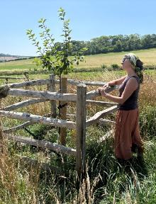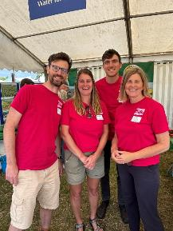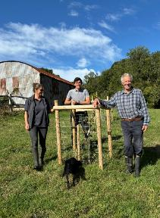
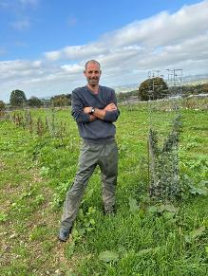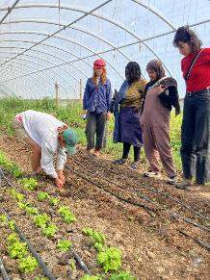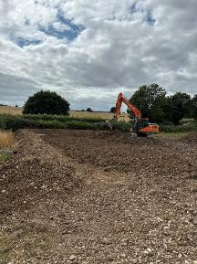

All photos © Rachel Janes (Dorset National Landscape)

COMMUNITY TREE PROJECT
Following consultation with parish and town councils, we have developed a project to support communities to plan for and plant trees that will contribute to nature recovery and survive our future climate, as well as being ‘the right trees in the right places’, appropriately cared for. The project is supported by Dorset Council, co-ordinated by the Dorset National Landscape Team, and covers the Dorset Council area. There are two main strands: a small grant fund to support the planning of tree planting projects, as well as community planting and engagement activities; and a pilot Volunteer Tree Warden scheme offering training and support for those parish and town councils who wish to participate.
Highlights:
- 21 Applications have been submitted.
- 12 projects have been approved for funding totalling £18,211.73 under the Dorset Community Tree Fund and are currently underway. Projects include support for two community orchards, two parish allotments and community greenspace planting, a community tree nursery, and two schools projects.
- Following on from the successful tree workshops with West Dorset primary schools last winter, a third round of workshops and tree planting sessions is being planned with 7 primary schools. This is a Community Tree Fund project led by the Dorset National Landscape team.

PEOPLE
This section explores the team’s work in helping people make a connection to this nationally important landscape and its special qualities. Some activities are specifically focussed on reaching underserved audiences in support of the Equality, Diversity and Inclusion principles.
Team members provide strategic input to Health & Nature Dorset, the Dorset Tourism Association, Food from England, etc.

STEPPING INTO NATURE/Nature Buddies Network
Stepping into Nature is in transition where it will still exist as a project but is no longer the lead project. The Nature Buddies Network project will work with partners to develop a network of trained volunteers who enable a person, on a one-to-one basis or as part of a small group, to overcome barriers to taking part in nature-based activities, such as a lack of confidence to get outside, to explore natural spaces and built heritage and to connect with nature. The project is funded by the National Lottery Heritage Fund and has been extended until September 2026. The team have appointed a Project Support Assistant for 10 hours per week. The team has engaged with an external evaluator Inside Heritage who have produced an Interim Report detailing project progress so far – Read here

Highlights:
Host Organisations & Volunteer Training:
- 4 host organisations onboarded: Upton Country Park, National Trust South-West, South West Coast Path Coastal Connectors, and Bere Marsh Farm (CRT).
- Nature Buddy training delivered to 21 individuals: 20 volunteers and 1 Ranger (Emily – Birds of BARI).
- 10 Nature Buddy activities offered across the 4 organisations.
- Nature Buddies Activity Finder webpage launched:
- 2 additional organisations in pipeline for future collaboration.
- 13 Community Nature Buddy volunteers recruited and trained in partnership with Volunteer Centre Dorset - These volunteers support clients in connecting with nature and heritage from home.

Resources & Training
- Promotional materials developed: Posters & leaflets to download & share - here.
- Nature Buddy resource packs created: A range of practical tools for volunteers.
- Nature Connection training fully developed and ready for rollout.

Promotion & Engagement
- Extensive promotion undertaken via libraries, councils, social media, newsletters, and website.
- 5 in-person promotional events attended.
- 2 webinars delivered (watch recordings here) and 1 presentation to a Primary Care Network.
- Regular social media posts on DNL platforms, 4 Reels showcasing Host organisations created and monthly enews out to 1,200 subscribers.
- New name for Picnic in the Parks is All Ways Out, launching soon! This is our digital platform packed full of ideas to explore the landscape from indoors or out.

Community Access Fund
- 9 projects funded to improve countryside inclusivity & accessibility.
- 4 projects completed, 5 in progress (on track for March 2026 completion).
- Next funding round opening in the New Year (c £15k pot for distribution).

Completed projects include: Accessible composting toilets at Tamarisk Farm, new accessible sit spot in Frampton, Woodland discovery trail at Thorner’s School, Quarry to Castle Trail, Burngate Stone Centre.

Upton Country Park Nature Buddies |  | Bere Marsh Farm Volunteers
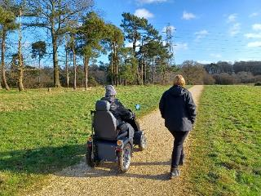 |  | 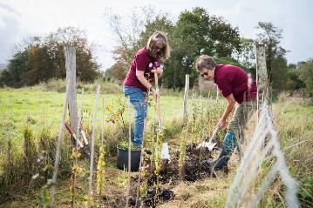
Emily, Nature Buddy at Holes Bay, Poole | Coast Path Connectors walk © Beth Carter
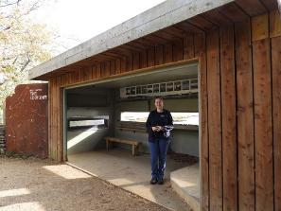 | 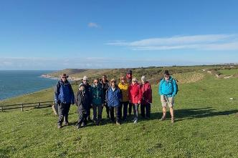

Over the next year we will continue to work towards building the network with promoting Nature Buddies to organisations/groups across the health, nature and heritage sectors to join the Nature Buddies Network.
Our current focus is working to generate referrals and extend our reach into BCP.

VISITOR MANAGEMENT
Dorset’s outstanding landscape is the main reason most people visit the area. The landscape underpins the tourism economy and plays a huge role in supporting local services. Visitor management is a loose term which encompasses many different projects. In essence, it is about managing the impact of visitors so that Dorset National Landscape retains its natural beauty and special qualities, while helping people to enjoy, understand and engage with the place. Since 2023, a focus has been on making the landscape more accessible to all. Working with partners, Dorset National Landscape has delivered a series of improvements that open up new opportunities for inclusive access. Through the Visitor, Tourism & Access Manager, the visitor management programme also extends across the Jurassic Coast, including East Devon, ensuring consistent and thoughtful visitor management across this iconic stretch.
Work for this period has mostly focused on:
- Improving Access for All in the landscape
- Reducing, rationalising and improving interpretation
- Replacing/ improving coastal safety signage

Highlights:
Access for All Initiatives: some completed; others in progress, to be completed by April 2026:
- Brownsea Island
  - A multi-terrain tramper has been purchased and delivered, enabling access across the island.
  - A new accessible ramp to be installed at “The Villa,” now a Visitor and Education Centre managed by Dorset Wildlife Trust.
- Highlands End
  - Track to be resurfaced to accommodate trampers, in partnership with West Dorset Leisure Holidays.
- Portesham to Abbotsbury Route
  - Accessibility improvements and resurfacing led by Dorset Council Greenspace team.
- Wareham Two Rivers Walk
  - Recycled plastic walkway installed to replace a previously flooded and muddy section, improving year-round access for all, including wheelchair turning spaces.
- Knoll Beach
  - New sea access to be created for people with disabilities and mobility limitations, in collaboration with the National Trust and an independent blue space access advocate.

Additional Visitor Management Projects:
- Lyme Regis Coastal Safety Signage
  - Six new signs installed along a popular multi-user walkway (East Cliff Sea Defence Project), using existing posts to reduce costs and waste.
- Charmouth Playing Field
  - A new landscape and wildlife interpretation panel installed to enhance visitor welcome and awareness of local natural features.
- South Dorset Ridgeway Signage (Planned)
  - Subject to funding, outdated signage will be replaced at key sites including the “Pit of Doom” and Blackdown near Hardy’s Monument.

Strategic Engagement:
Sally now represents tourism, visitor management and access interests on the newly formed Jurassic Coast Steering Group, helping shape collaborative decisions to protect and enhance the World Heritage Site and guide its new Management Plan.

Full details in Appendix
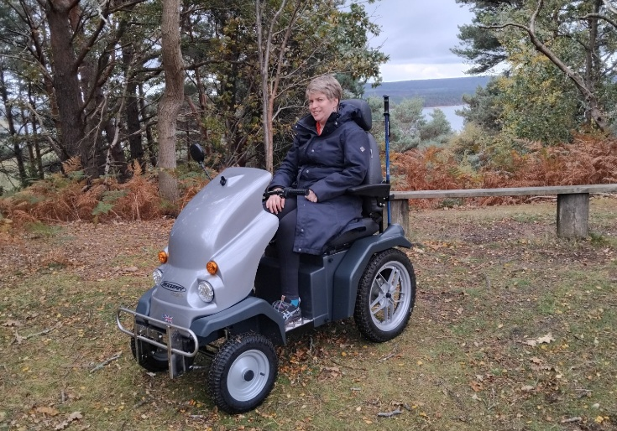 | 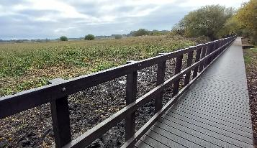

“The interpretation panel came yesterday, just in time to be on
display for our Full Council meeting last night! It is absolutely beautiful and the whole
Council are thrilled with it. Thank you so much for your expertise.”
Lisa, Charmouth Parish Council

FLAVOURS: A taste of Dorset’s outstanding landscape
The FLAVOURS programme is led by the Dorset National Landscape, in partnership with Dorset Race Equality Council, Activate Performing Arts, Dorset Food and Drink and with support from BPC Indian Community, Dorset Ukraine Community and the National Lottery Heritage Fund. The programme has building relationships between Dorset’s ethnically diverse communities and the landscape.

Last year the project over-delivered on targets and also underspent on budget, which has enabled an extension of activity ending in December 2025. This summer we have continued working with 8 communities and developing bespoke visits to the countryside which have been rich experiences for communities and partners alike. This year we have involved 371 community members in 7 days out to the countryside including Durlston Country Park, Upton Country Park, Blue Pool and Corfe Castle.

Artists have been a big help for the Flavours visits, helping us to facilitate the groups in an inclusive way and also to enhance the connection to nature through creative activities. Activate have recently run a successful Flavours training event for artists to recruit more artists to take on this role in future events.

A toolkit of films and web-based information is being created for our community groups, to build confidence to take further visits to the countryside independently.

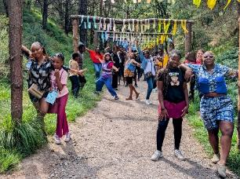 | 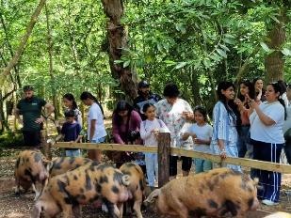
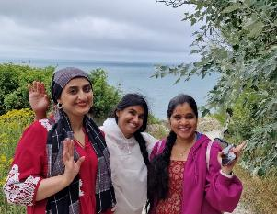 | 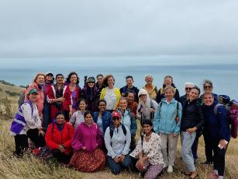
Top: Nigerian Community visit to Blue Pool; Grace the Space visit to Durlston
Bottom: Grace the Space participants at Durlston; BPC Indian community visit to Blue Pool
All © Dorset National Landscape

NATURE CALLING
This national project led by the National Landscape Association has given us invaluable connections to underserved communities in Yeovil and culminated in a new Giant for Dorset being displayed on prominent hills throughout September.

We invited 6 community groups and schools from Yeovil out to Cerne Abbas in May, where we explored the Giant and beautiful springtime nature of Giant Hill. Artists from Radical Ritual then engaged them in creative workshops based on the game of Consequences. Using the community artwork to create a new Giant for Dorset that was launched alongside the Cerne Abbas Giant in September. This attracted national media interest and reach, you can see the article and launch film on the Guardian website.

After Cerne Abbas, the 40m long Giant was pitched at Summerhouse Hill in Yeovil, where a joyous parade of over 50 local people welcomed the Giant to Yeovil. Next stop, the Giant appeared on the slopes of Corfe Castle as part of the Inside Out Dorset festival.

We are working with Radical Ritual, Activate Performing Arts (producers) and National Landscapes Association to evaluate the reach of the project and a full report and film will be available at the next meeting. We have already reconnected with the groups and hope to develop relations with them further over the coming year.

My son told me he'd painted the giant's feet with his primary school, so I came with my older son to join the parade. We carried banners that said Together We Are Giant and were amazed to find my son's picture inside the giant's foot. We felt so proud. Next time my son tells me we have to go to something, I'll take notice. Audience member

Highlights:
- Nature Calling has connected us with over 200 people from Yeovil community groups, who are keen to do further nature based activities with us in the future
- The Consequences Giant artwork was seen live by over 27,000 people in September and had an online audience of more than 64,000 people
- Artistic legacy of the project also includes ‘This patch of land’ prose poem written by Louisa Adjoa Parker; Consequences Giant soundtrack composed by musician Douglas Dare; and illustrated written work by author Nick Hayes.
Find out more:
- The national Nature Calling programme
- The Nature Calling project in Dorset
- The creation of the work – see reels on the Radical Ritual website.

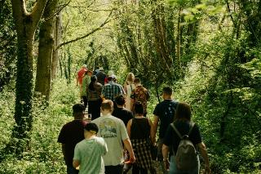 | 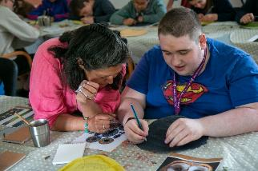
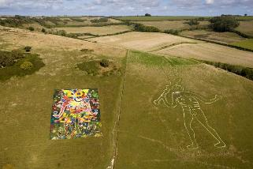 | 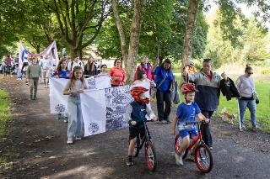
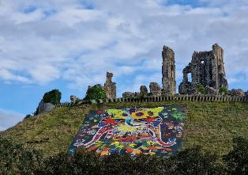 | 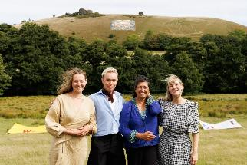
Top row: Group visit to Cerne Abbas © Ben Ingram; Sita Brachamari at community workshop © Activate
Middle row: Consequences Giant unveiled at Cerne Abbas © David Levene; Community parade at Yeovil © Lindsey Harris
Bottom row: Consequences Giant at Corfe Castle; Radical Rital artists with Daniel Dare © Roy Riley

PROMOTING THE NATIONAL LANDSCAPE
A new Explore leaflet has been developed and has been distributed to key visitor outlets this summer, which includes a newly designed map. Further upgrade work has been done to the Dorset National Landscape website (including accessibility audit an better map functionality).

Social media engagement has increased over the summer due to active projects and campaigns.
- Increased engagement across all social media platforms: total followers increased for Facebook to 6342, Instagram to 2763. Our X account has 9135 followers but we no longer use this channel and are trialing posts on BlueSky and LinkedIn instead. On Facebook, a total of 123 posts have attracted 227k views and 3990 Likes. On Instagram, a total of 143 posts have attracted 64k views.
- A new set of Explore reels have been commissioned to highlight different sites and/or different seasons.
- New social media campaigns focussed on Nature Buddies, Nature Calling, FIPL case studies, Beautiful Places to Explore reels, event promotion, project news and updates. New campaigns have been developed to highlight the special qualities of the National Landscape.
Website: www.dorset-nl.org.uk Facebook: @DorsetNL Instagram: @dorsetnationallandscape
X: @Dorset_NL Bluesky: @dorsetlandscape LinkedIn: @Dorset National Landscape

PLACE
This section encompasses the team’s role in place-making – input to the planning system and conserving, enhancing and promoting the area’s culture and heritage.

PLANNING PROTOCOL WORK

The Team received 144 consultations from April 2024 – October 2025, this being a slight decrease from the proceeding year, which had the second-highest volume of consultations recorded. These consultations include planning proposals, felling licences, woodland management plans, marine licence applications and requests from statutory undertakers, particularly electricity distribution companies.

Highlights:
- The Team has provided a comprehensive response to the Dorset Local Plan options consultation.
- The team has been involved in some high-profile minerals planning cases, including an appeal hearing for a proposed extension to Downs Quarry (Purbeck Stone). We are also engaged in discussions concerning an extension to Povington Pit (ball clay), where a landscape enhancement fund may be established.
- Major renewable energy proposals within and close to the National Landscape are an ongoing area of work. A revised application for a solar farm at Cruxton, near to Maiden Newton, was recently refused at committee and a further appeal is expected.
- The Team continues has been responding to a number of woodland creation proposals, reflecting the availability of grant funding opportunities from the Forestry Commission.

DORSET FOOD & DRINK
The future of Dorset Food & Drink CIC (DF&D) is still dependant on its ability to navigate current challenges and adapt to a changing environment. Striking a balance between daily operations, strategic planning, and staying competitive will be key to its ongoing success. This ambition placed considerable pressure on the current Coordinator, whose time and capacity was stretched across multiple priorities.

In 2025, Dorset Food & Drink will evaluate its core identity, and strategically reposition itself to align with its evolving goals and values to better serve:
- Our member community
- The wider public
- Potential corporate partners
- The food conversations and ambitions of Dorset Council, Visit Dorset, BCP and other nearby regional food projects. (Hampshire Fare, Devon Food & Drink and Food Works in Exeter) To explore business opportunities, collaborations, and meet the buyer showcases for food and drink businesses ready to expand.

Highlights:
- Our 2025 core events include: The Abbotsbury Swannery Food & Craft Fair, The Dorset Food & Arts Festival and a Winter Food Fair at Athelhampton; all have concluded successfully.
- Ongoing collaboration with Dorset Farmers Markets.
- Securing £10k from the Rural Prosperity Fund via Visit Dorset to commission a series of short films showcasing Dorset’s food scene and some of the producers.

DORSET FINGERPOST PROJECT
Dorset’s iconic fingerposts, timeless fixtures of the rural landscape, have faced significant decline, with many in disrepair. As Dorset Council no longer oversees their maintenance, restoration efforts rely on community dedication. In partnership with Roger Bond of Normtec and his skilled team of volunteers, the Dorset National Lanscape are proud to fund and support the restoration of these historic landmarks, safeguarding Dorset’s cultural heritage for future generations.

Highlights:
- Restoration of 27 fingerposts and 12 brackets across various Dorset locations, including Chesil Bank, Burton, Hillfield, Higher Waterstone, Portesham, Broadwindsor, Evershot, West Morden, Lytchett Matravers, Hilton, Marnhull, Corsecombe & Halstock, Manston, Winterbourne Stickland, Netherbury, Bradford Abbas, Ansty, Gillingham, The Ridgeway, Cheselbourne, Comptons, Toller & Wynford, and Beaminster.
- The restoration efforts encompass 22 diverse sites, including Parish, Town, and Dorset Council locations, ensuring a comprehensive approach to preserving these historic landmarks across the county.
- The new website, https://www.dorsetfingerpostrestorers.co.uk/ provides comprehensive information and updates on the Dorset fingerpost restoration initiative, where you can also view the ongoing work and meet the dedicated team behind the project.

"Our dedicated Fingerpost Champions, expertly guided by Roger Bond of Normtec and supported by CPRE funding, are revitalising Dorset’s historic fingerposts for the enjoyment of future generations."

Find out more about the Dorset Fingerpost Project

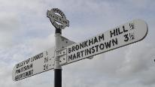 | 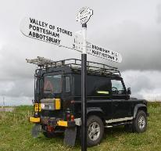 | 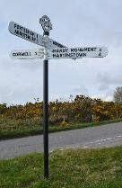

>>>>>>>>>>>>>>>>>>>>>>>>>>>>>>>>>>>>>>>>>>>>>>>>>>>

UPDATE ON PROPOSAL TO BID FOR FUNDS
ITEM FOR | Information | REPORT BY | Dorset National Landscape Manager
SUMMARY | In November 2024, the team proposed two major bids for funds. The Landscape Recovery opportunity has not yet arisen, and the Landscape Connections proposal has been kept on hold for the management planning period.
FINANCIAL IMPLICATIONS | Landscape Recovery could provide £750k over two years to develop a multi-million, 20-year programme of land management.  Landscape Connections could provide up to £10 million for up to 8 years of delivery.
RECOMMENDATION | The Dorset National Landscape Board notes the update

  - LANDSCAPE RECOVERY
Landscape Recovery sits alongside the Sustainable Farming Incentive and the Countryside Stewardship scheme making up Environmental Land Management. It is intended that Landscape Recovery delivers significant land use change.
Two rounds of pilots have been launched already; in the first round 22 areas and in the second round 34. Within the Dorset National Landscape, Wareham Arc and the Upper Axe Catchment are round 1 pilots, the Brit Catchment a round two pilot.
Each pilot is expected to bring together multiple land holdings to design and commit to a bespoke, long-term (20+ years) programme of environmental delivery. This programme is to be costed with some prospect of blended finance (private contributions supporting outcomes underpinned or de-risked by the national public farming budget). Each pilot area is expected to have a single agreement with Defra, and to this end many are establishing independent bodies such as Community Interest Companies.
Pilots are supported for two years with development funding from Defra to devise this costed land management plan, the blended finance package, delivery governance arrangements and an extensive monitoring and evaluation programme.
- A third round of pilots is ready to be launched, awaiting ministerial sign-off and budget confirmation as part of Defra’s business planning process. It is unlikely there’ll be any announcements before Jan/Feb.

  - LANDSCAPE CONNECTIONS
Landscape Connections is one of the National Lottery Heritage Fund’s strategic initiatives and was launched in the summer of 2024. Seen as a successor to the Landscape Partnership programme, this is designed to support a landscape approach to nature recovery, heritage and culture conservation and enabling people’s access and appreciation to it. Successful projects must deliver the NLHF’s core investment principles (save heritage; protect the environment; inclusion, access & participation; organisational sustainability).
It is one of the larger grant funds available at a maximum of £10M for up to 8 years of delivery.
- It was our original proposal to submit a small bid to support a development phase. Team capacity was limited this year due to project commitments and management plan review so this wasn’t possible. The management plan review process, however, has given us plenty of material to work on. Meetings with partners to work up a programme of delivery will start in Jan/Feb.

>>>>>>>>>>>>>>>>>>>>>>>>>>>>>>>>>>>>>>>>>>>>>>>>>>>

BUDGET HEADLINES 2026-2027
ITEM FOR | Information | REPORT BY | Dorset National Landscape Manager
SUMMARY | Following a Spending review in which Defra received a real-terms cut and known financial constraints in Dorset Council’s budgeting, this forecast is made on the assumption of a core offer the same as this financial year with no uplifts (revenue & capital) which this year’s budgets include.  We hope the Defra settlement will be known in January 2026.
FINANCIAL IMPLICATIONS | This item covers broad Dorset National Landscape finance projections for 2026-2027
RECOMMENDATION | The Board approves the proposed budget and funding priorities for next financial year

  - Dorset National Landscape budget structure & Defra guidance
The budget is split into 2 areas: Core and Projects. Funds from Defra, our majority funding partner, are provided according to the ‘single pot guidance’ as set out below.
    - CORE: Core Functions are critical to the successful operation of National Landscape Partnerships.
Within core functions it is to be expected that staffing and associated overheads should merit particular protection. As set out in the Defra grant offer letter the grant offer includes a maximum contribution to core funding of 75% and is conditional on Partnerships securing match funding of a further 25% of core funding from other sources. It is hoped and expected that Local Authority partner contributions to all Core Functions continue at a minimum of 25%, or even at the same levels that have previously been invested.
Contributions from bodies other than local authority partners and/or earned income can be used to support core functions; this would release Defra-origin funds for other activity. Core Functions are defined in the Defra MoA and as such provide guidance on minimum standards to allow successful operation of a National Landscape unit and the delivery of the National Landscape Management Plan.
    - PROJECTS: National Landscape Partnerships are free to determine how they use resources to deliver projects. If 100% National Landscape project funding is the only way to achieve the desired outcome, this is for the Partnerships to decide in developing their programme. Defra believes that delivery of National Landscape Management Plan objectives is generally greater and more sustainable if undertaken in partnership, particularly for large scale or landscape scale projects. It therefore encourages all National Landscape Partnerships to use their project funding to help lever in additional resources. The ability and willingness of partners to contribute to projects will be variable from partner to partner and from year to year. It is recognised that staffing costs can be met by project funding.

  - Current year as basis of assumptions: Defra core contributions
    - Core contributions from Defra must not exceed 75% total core spend.
    - The Dorset National Landscape Partnership receives a core grant of £283,705.00
    - In this current financial year, we also receive a sum of £375,717 of CDEL (capital) funds; this is not expected to be matched by local contributions.
    - This is also accompanied by FIPL (£797,615) and Access for All (£198,874). Whether we are to receive any grant under these headings will be determined by Defra’s business planning process.

  - Current year as basis of assumptions: Core match funding
    - In the current financial year, the Dorset National Landscape Partnership receives a contribution of £53,600 from Dorset Council. This alone is insufficient to make the required 25% match.
    - The team has a core income target of around £47,000 to make up the necessary match. In reality this requires team members to extract project management income to support the core budget, which in effect reduces capacity for non-project delivery. Much of this income also relies on FIPL.

  - CORE COSTS
Efforts continue to ‘projectise’ a reasonable proportion of the team’s overheads depending on any restrictions imposed by the funding body: all projects make a contribution towards accommodation at a minimum.

  - INCOME FORECAST
Note significant increase from 24-25 of other income required. This strategy will consume the reserve, increasing the need for a better core settlement from Defra in subsequent years.

  - PROJECTS & SDF
Currently, this forecast leaves no additional core funding for a small grants fund nor contributions to projects. Current projects do not require Defra revenue grant; if we receive capital funds we will seek to deliver for projects from this. In this current year, for instance, several Access for All projects are being counted as match for Nature Buddies.

>>>>>>>>>>>>>>>>>>>>>>>>>>>>>>>>>>>>>>>>>>>>>>>>>>>

Partner updates

Each National Landscape Board Member is invited to use no more than 2 minutes to describe the main issues and opportunities relevant to National Landscape Management from their organisation’s perspectives.

>>>>>>>>>>>>>>>>>>>>>>>>>>>>>>>>>>>>>>>>>>>>>>>>>>>

APPENDIX 1: detailed National Landscape team activity log
This content is in addition to the Team Activity report in item 4

FARMING IN PROTECTED LANDSCAPES
Some 25/26 highlights relating to the four themes include:
Nature
- Four Duke of Burgundy Butterfly Critical Sites and Habitat connectivity projects have been supported responding to actions recommended in a FiPL funded study of 31 land holdings in the Cerne and Sydling Valleys (Circa £100k of funding).
- 137 more fruit trees are planned to be planted this winter which will make the total for the FiPL programme 846 trees including walnut, apple, pear, cherry, cobnut, medlar and plum across more than 20 sites.

Climate
- FIPL is on track to plant 15km of hedgerow within the 5 years of the programme, including 3.9km in 25/26.
- Five projects to deliver flood alleviation and soil resource protection have been funded (circa £100k total). Combinations of swales, bunds, cross-drains, leaky dams, hedge and tree planting will slow flows in ‘hot spot’ locations.
- Knowledge Exchange events have been delivered to encourage the uptake of regenerative farming.
- Investment in Purbeck coast farm businesses – refurbishment of buildings for conservation grazing business, purchase of machinery including compost turner, disc spreader and inter-row how as investment in regenerative farming collaboration – reducing fertiliser and fungicide use.

People
- Projects have been supported which include elements to widen participation in the Protected Landscape including outreach to offer 62 children in receipt of frees school meals in Purbeck being funding for a ‘night under the stars’ in the Big Purbeck Campout delivered by Land & Wave as part of Purbeck Goes Wild network.
- Open Farm Sunday in June also say the official opening of the Home Farm, Sadborow FIPL funded classroom, and the FiPL team also supported Discover Farming at the Melplash
- Create 0.75ha of wildlife corridors to increase habitat connectivity
- Agroecological and regenerative farming skills training for people from diverse backgrounds at Tamarisk and Fivepenny farm have been/will be delivered this financial year.

Place
- As part of a wider project delivering educational and nature outcomes, a purpose built facility for utilising excess organic milk by turning into icecream has been funded at Liberty Farm.

VISITOR MANAGEMENT
Detailed outputs and outcomes:

Interpretation and signage
- 6 new (replacement) interpretation panels installed Charmouth foreshore and village, and 2 new (replacement) beach safety signs installed at Charmouth East and West Beach, working with relevant partners such as Charmouth Heritage Coast Centre, the Jurassic Coast Trust and RNLI. These were fully funded by the Parish Council, including a Project Management fee to Dorset National Landscape for managing and delivering the project
- Replacement ‘over stickers’, showing new Dorset National Landscape branding, professionally attached to welcome and orientation signage at Wareham station

